
AWS Lab 1-3
Ian Kwan - CCNA
Purpose
To explore and understand the fundamentals to using AWS services and creating a functional network system using cloud infrastructure.

Background
Amazon, founded by Jeff Bezos in 1994, started off in a garage in Washington. It started off as a bookstore from a garage but quickly took to the internet as an online bookstore selling products through its website. This company took off and went beyond books, selling other products and buying other online book companies in foreign countries, becoming an international operation.
AWS Cloud
In 2002, Amazon launched a new computation-based branch called Amazon Web Services (AWS). It started off helping web developers build their applications. But as it grew, AWS expanded further, providing other services like providing cloud storage and cloud compute power. Using a pay-as-you-go model, AWS allows users to access AWS services and the AWS cloud with the intent of benefiting users by saving costs on overhead costs of physical servers and making scaling and securing servers easy.
Cloud Security
An interesting fact about the AWS cloud system is that thousands of users are actively using servers and other devices across AWS regions, but the physical location of those servers is not disclosed. Amazon has developed a complex system of AWS regions and Availability zones to maximize reach across the globe to provide their service to consumers across hundreds of countries while also maintaining the protection and security of user data. Under the AWS shared responsibility model, the user is responsible for securing the encryption of data at rest and in transit while Amazon is responsible for the security of infrastructure that runs the clouds by maintaining physical security of the network devices being used.
Amazon IAM
The Amazon Identity and Access Management (IAM) service highlights Amazon’s dedication to providing customers with the proper security to protect their data. The AWS cloud is designed to feel and be as secure as an on-premises server center. Amazon IAM functions as the verifier and authenticator of users to control access to customer data. Under the AWS shared responsibility model, Amazon IAM falls under the customer’s responsibility to be configured correctly by following the IAM best practices. Amazon IAM can be broken down into two main categories, authentication and authorization.
Firstly, Amazon IAM provides security for users by ensuring the proper authentication of users attempting to access customer data. To secure access to AWS services and the user data attached, IAM secures programmatic access and AWS management console access. Programmatic access involves authenticating the user with an access key ID or a secret access key. After verification, the user would have AWS CLI and AWS SDK access. AWS management console access involves authenticating the user with a 12-digit account ID or an alias as well as an IAM username and password. In addition to verifying the user with log in credentials, IAM also has an additional layer of security call MFA. If applied, it would require a unique authentication code in addition to the user’s username and password.
Secondly, Amazon IAM provides security through authorization by controlling the level of access a user has. The main method used to control this form of access is though IAM policies based on IAM users, IAM groups, and IAM roles. IAM policies control what services a user under that policy can access. These policies are all in the JSON format and function like an ACL. By default, IAM policies implicitly deny access and need to be configured specifically to allow certain traffic to pass. Implicit denying paired with the best practice principle of least privilege maximizes the security of an AWS account. IAM policies can be defined through the resource. These resource-based policies specify who can access the resource and what permissions these users have, limiting the actions unauthorized users can perform. IAM policies can also be defined through the concept of IAM users. IAM policies can be directly applied to certain users which authenticate and authorize the user to perform certain actions. IAM policies can also be applied through IAM groups which apply the same permissions to a collection of IAM users. And finally, IAM policies can be applied through IAM roles. Though like an IAM user, in that it authenticates and authorizes a single individual, it differs slightly in that an IAM role is not associated with any one person. Instead, IAM roles should be seen as temporary credentials which give access to a person, application, or service. An example would be if an application on one AWS service needs access to another service. Then, an IAM policy allow access would be applied through the appropriate IAM role.
Amazon VPC
The Amazon Virtual Private Cloud (VPC) is a service that promotes user privacy on the cloud. It provisions a section of the cloud that is logically isolated while still permitting the use of AWS services. Amazon VPC creates multiple layers of security and gives more control over network configurations to users. When creating a VPC, users must assign their VPC to a dedicated IPv4 CIDR block. There is a limit to the size of this IPv4 CIDR block which is required to be between /16 to /28 in subnet size. IPv6 CIDR block are also supported with their own respective minimum and maximum block sizes. Subnets can also be added within the VPC CIDR block allowing further customization of the network. In each subnet 5 addresses are reserved. Just like in an on-premises network the network address and network broadcast address IP are reserved. But in addition, the first, second, and third IP addresses of the network are also reserved for Internal communication, Domain Name System (DNS) resolution, and Future use respectively.
AWS EC2
The Amazon Elastic Compute Cloud (EC2) involves virtual machines (VMs). EC2 instances can serve many purposes like application servers, web servers, database servers, and more. The benefit of Amazon EC2 instances is how they provide users with access to VMs without the need to pay for physical hardware or storage capacity which are required in an on-premises data center. Using Amazon EC2 instances, users only pay for the VMs that they use, saving costs and time. An Amazon EC2 instance can be launched in two different ways. But both ways require users to configure and specify their desired network configurations. The first method requires users to configure the Amazon Machine Image (AMI), the instance type, the key pair, and more. The other method is more technical, requiring users to use the AWS Command Line Interface (AWS CLI) to configure everything about their instance.
Configuration
Lab 1 – Introduction to AWS IAM

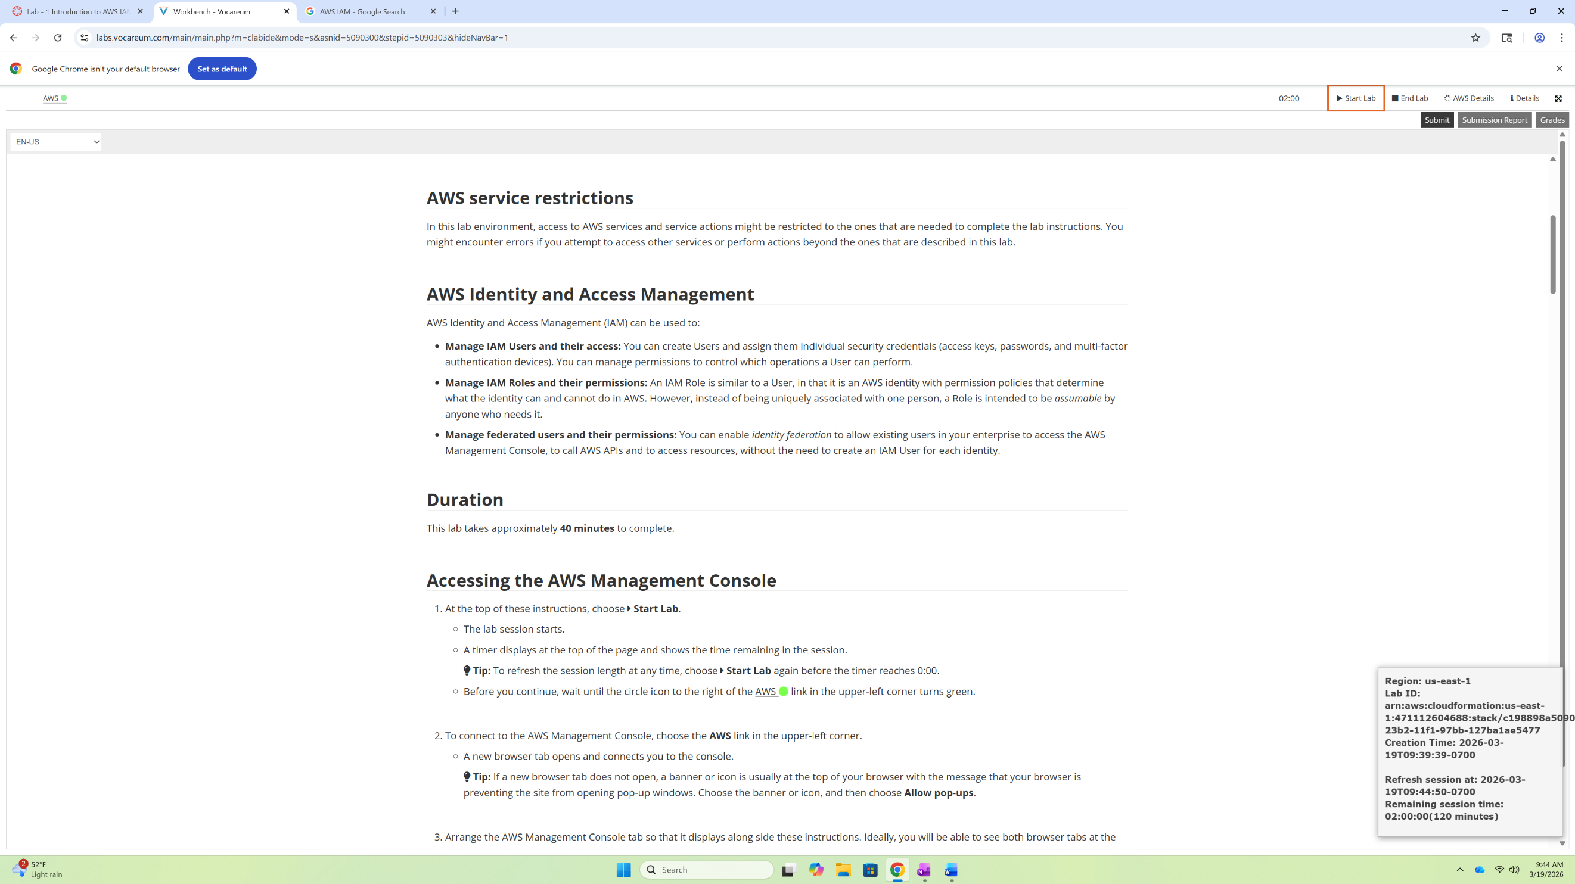

To get started, click the “Start Lab” button in the top right-hand corner and wait for the AWS link to show a green status, shown below.

Click the AWS link in the top left corner to begin the lab. Note: make sure that the status of the link is green before clicking.

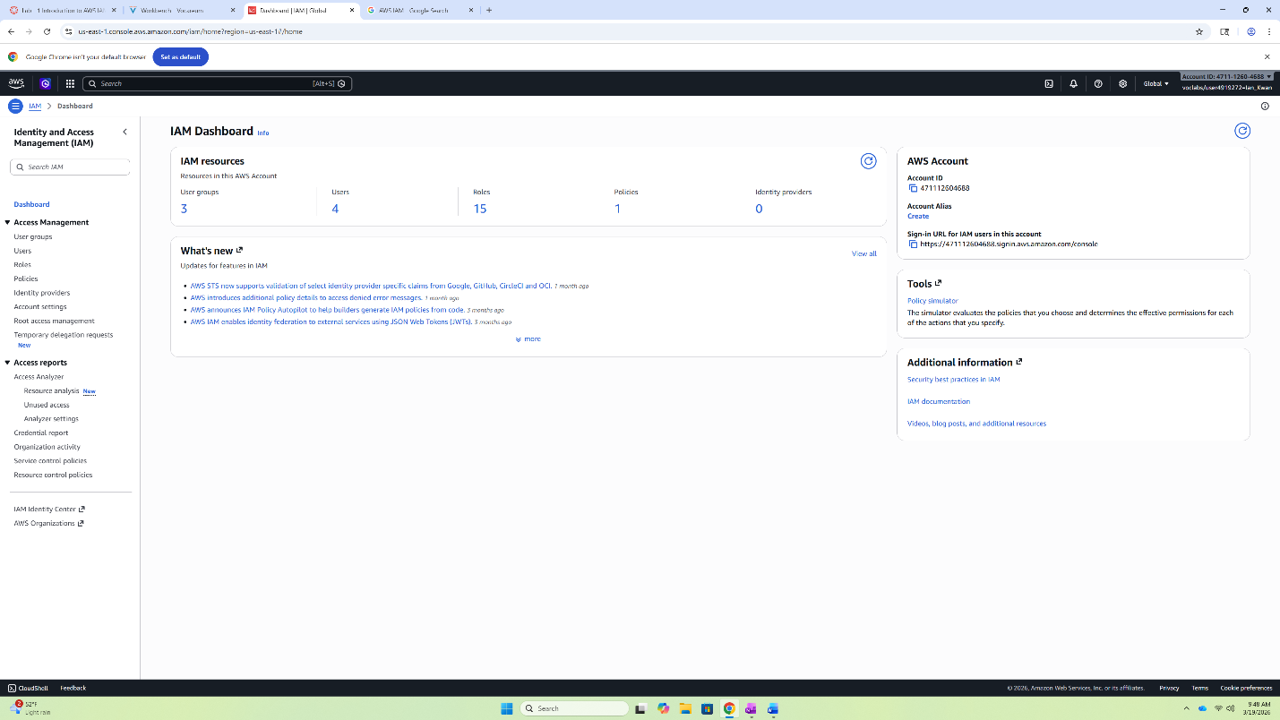
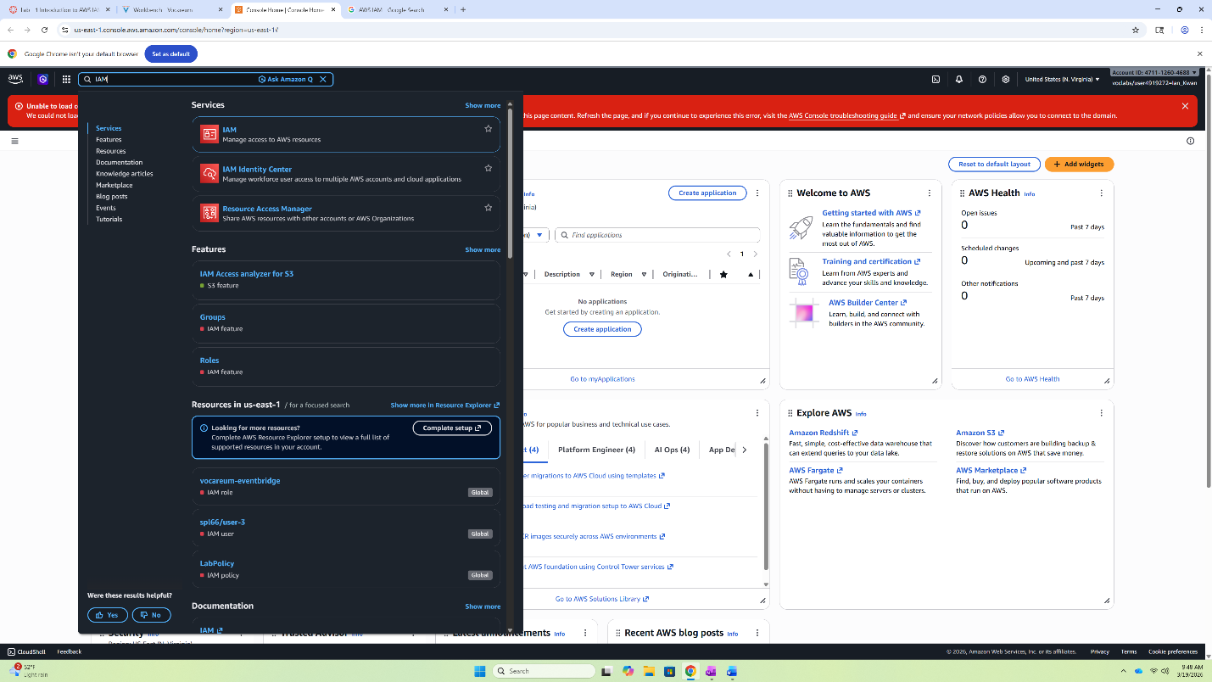
Clicking the AWS link will bring you to the AWS management console. Here, click the search bar in the top left and type in “IAM”. Then select the IAM link beside the icon.

Now, you have entered the IAM Dashboard. Select “User” in the left side bar under Access Management.

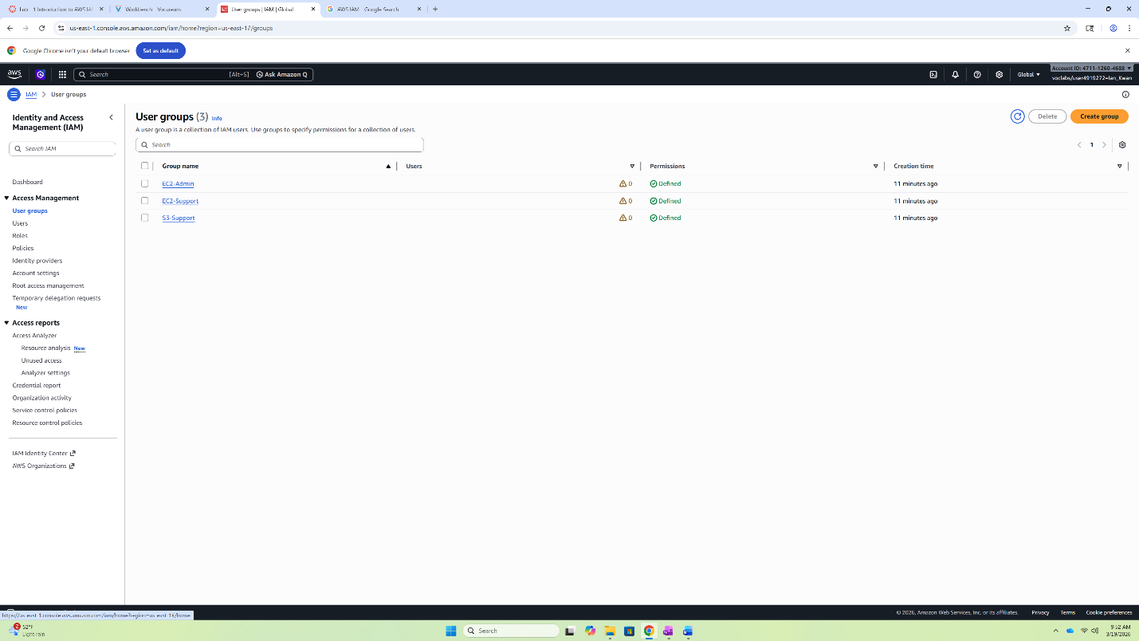
The in the User group menu, you will see a list of IAM groups. Here, select the link for “S3-Support” by directly clicking the link.

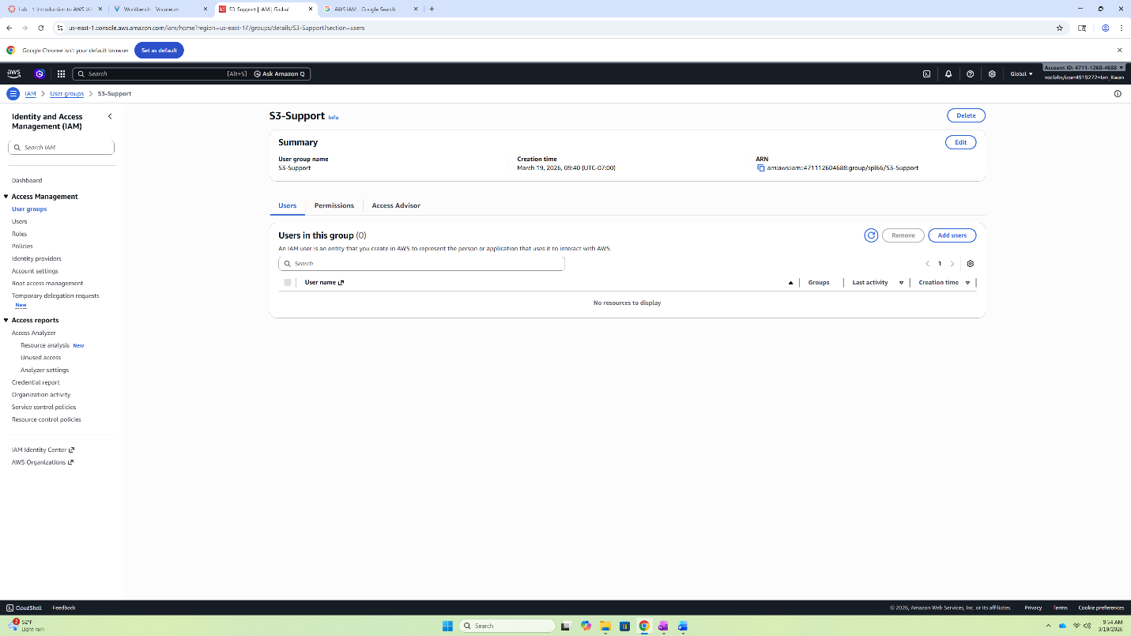
In the S3-Support menu, select the “Add users” icon.

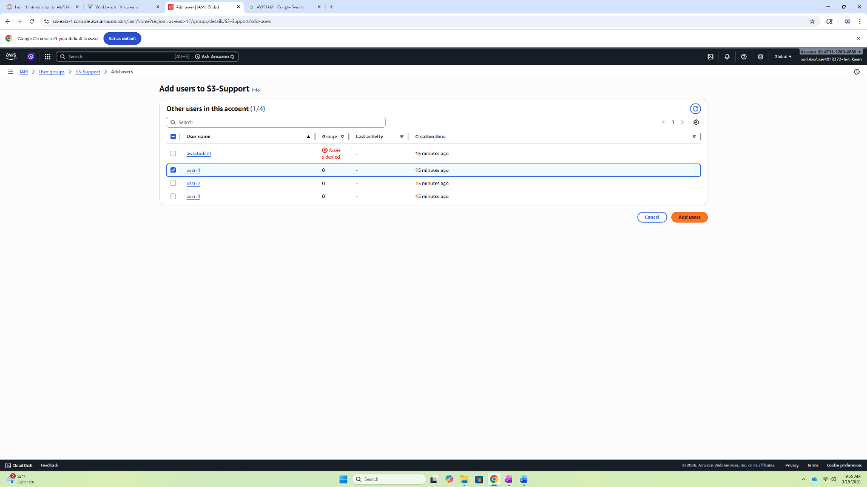
You can either search user-1 up or just select the check box besides the title user-1 and then select “Add users” in the bottom right corner. Congrats, you just added a user into an IAM group.

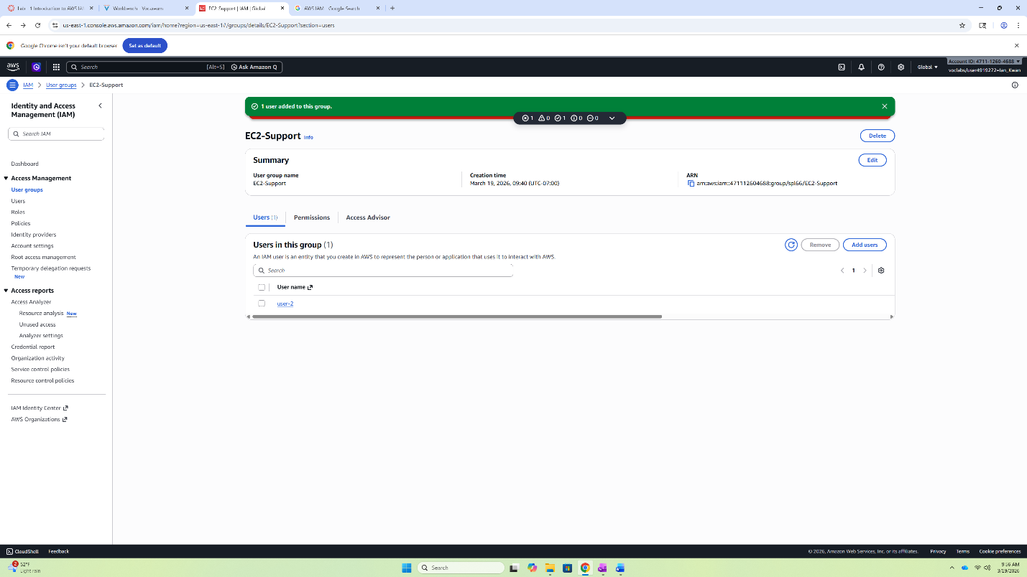Now, using the same steps add user-2 into the EC2-Support group.

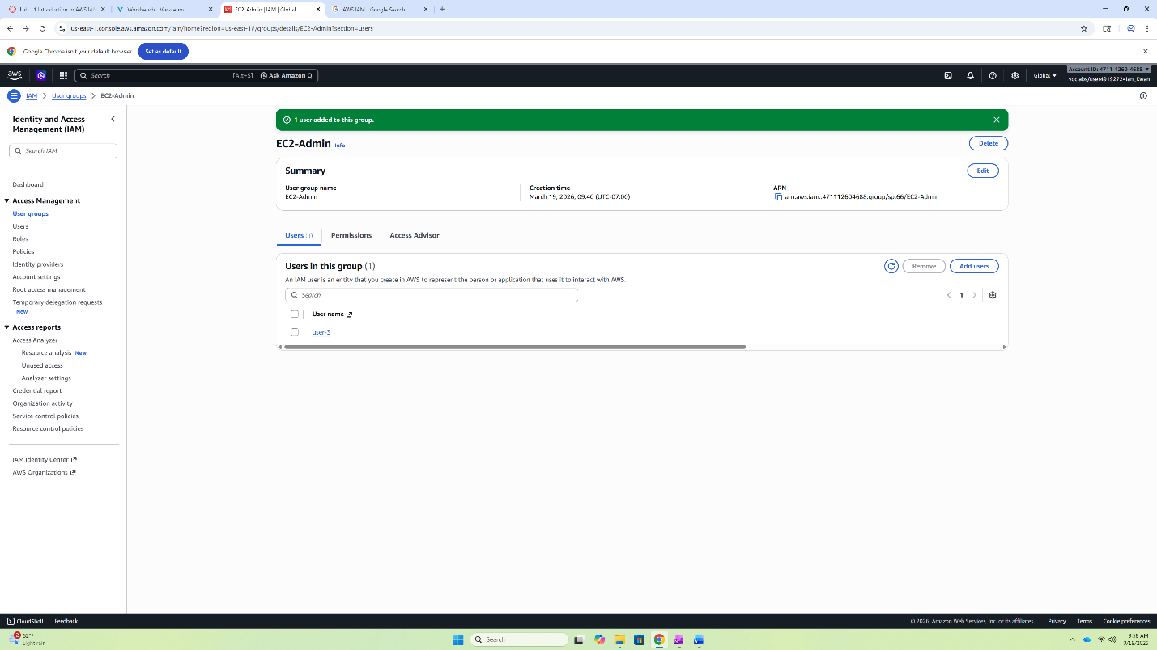
And using the same steps again add user-3 into the EC2-Admin group.

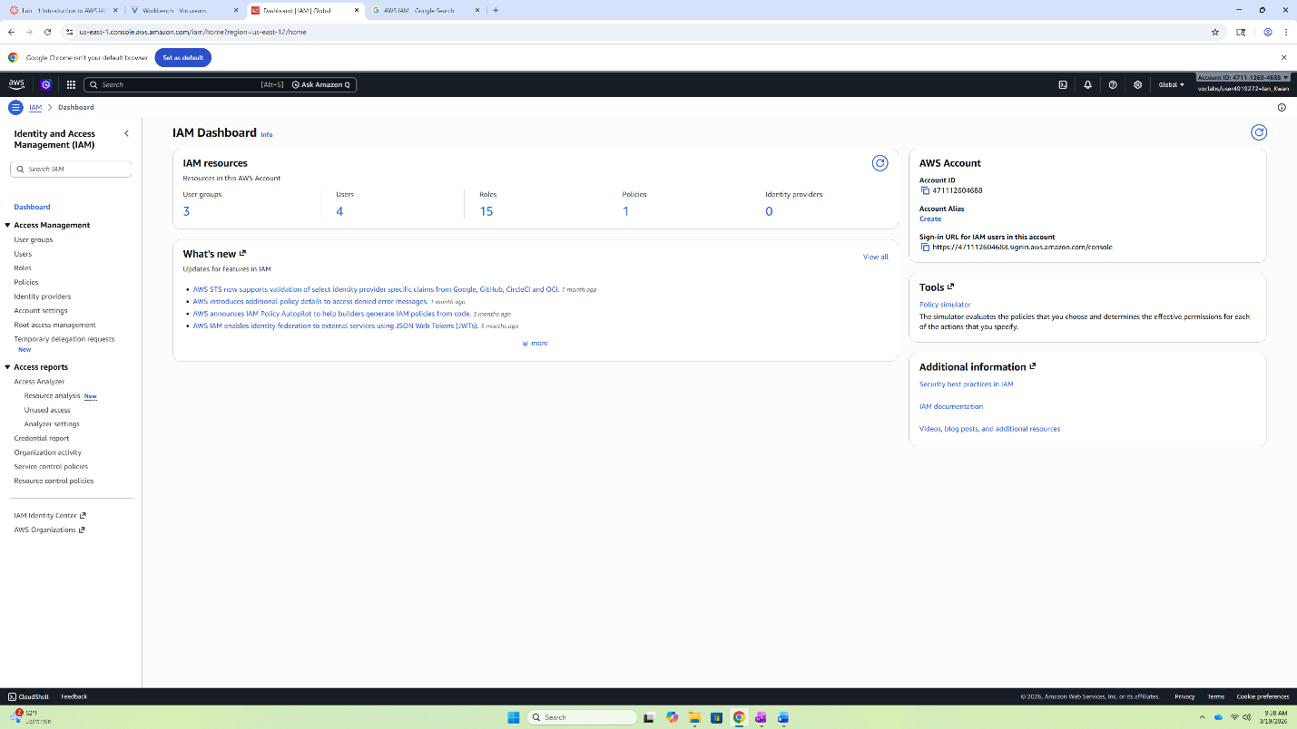
Now, head over to the IAM Dashboard by clicking Dashboard on the left side bar.

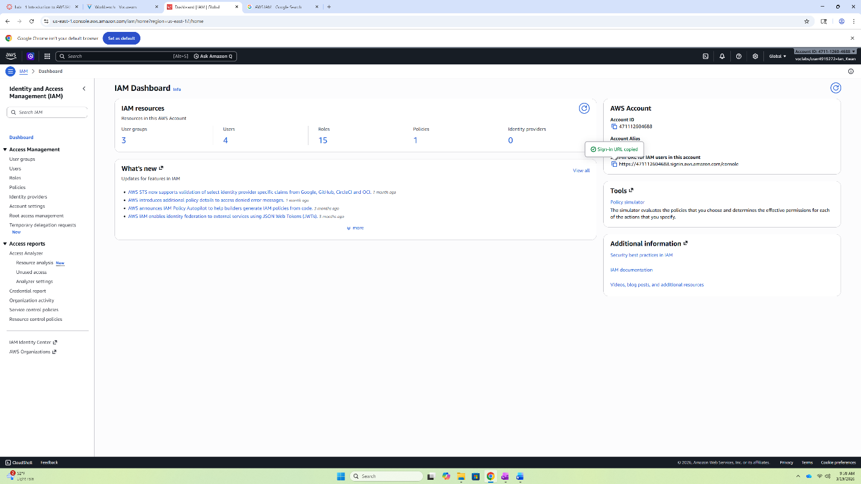 Then copy the sign-URL on the right under AWS Account.

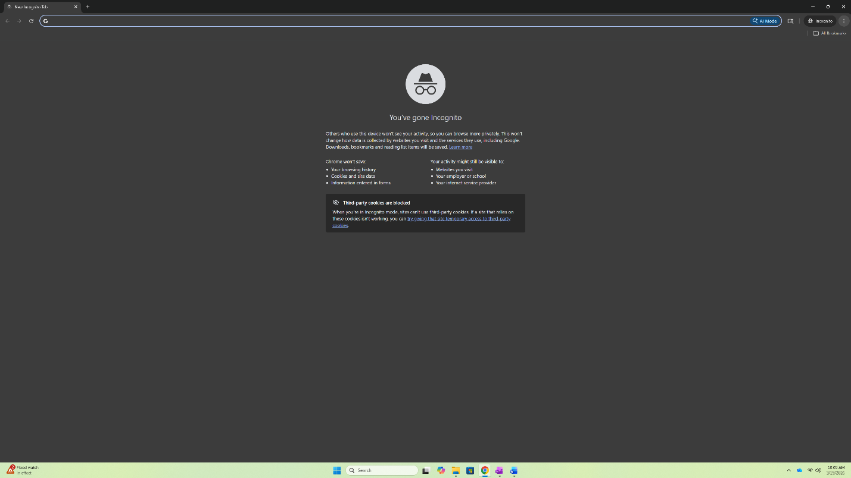
Open an Incognito tab. A shortcut on Windows is Ctrl+Shift+N. Paste in the copied link and log into user-1.

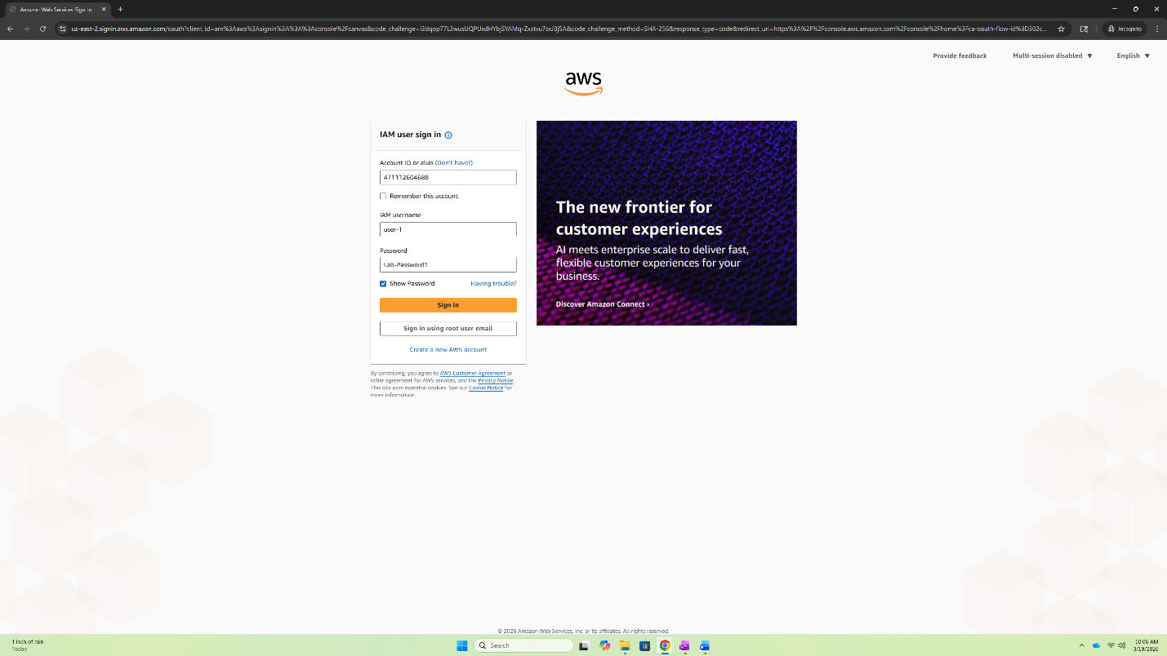
Here are the credentials for user-1.
IAM username: user-1
Password: Lab-Password1
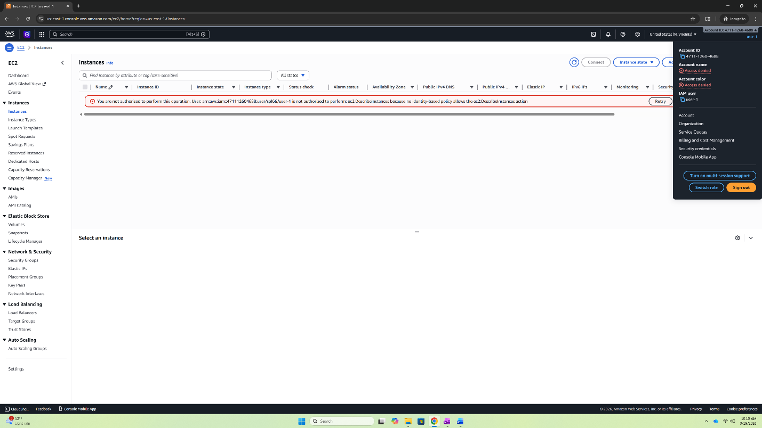
After logging in, you may explore the permissions given to user-1 by accessing S3 bucket. Then click the tab in the top right corner and click “Sign out”.

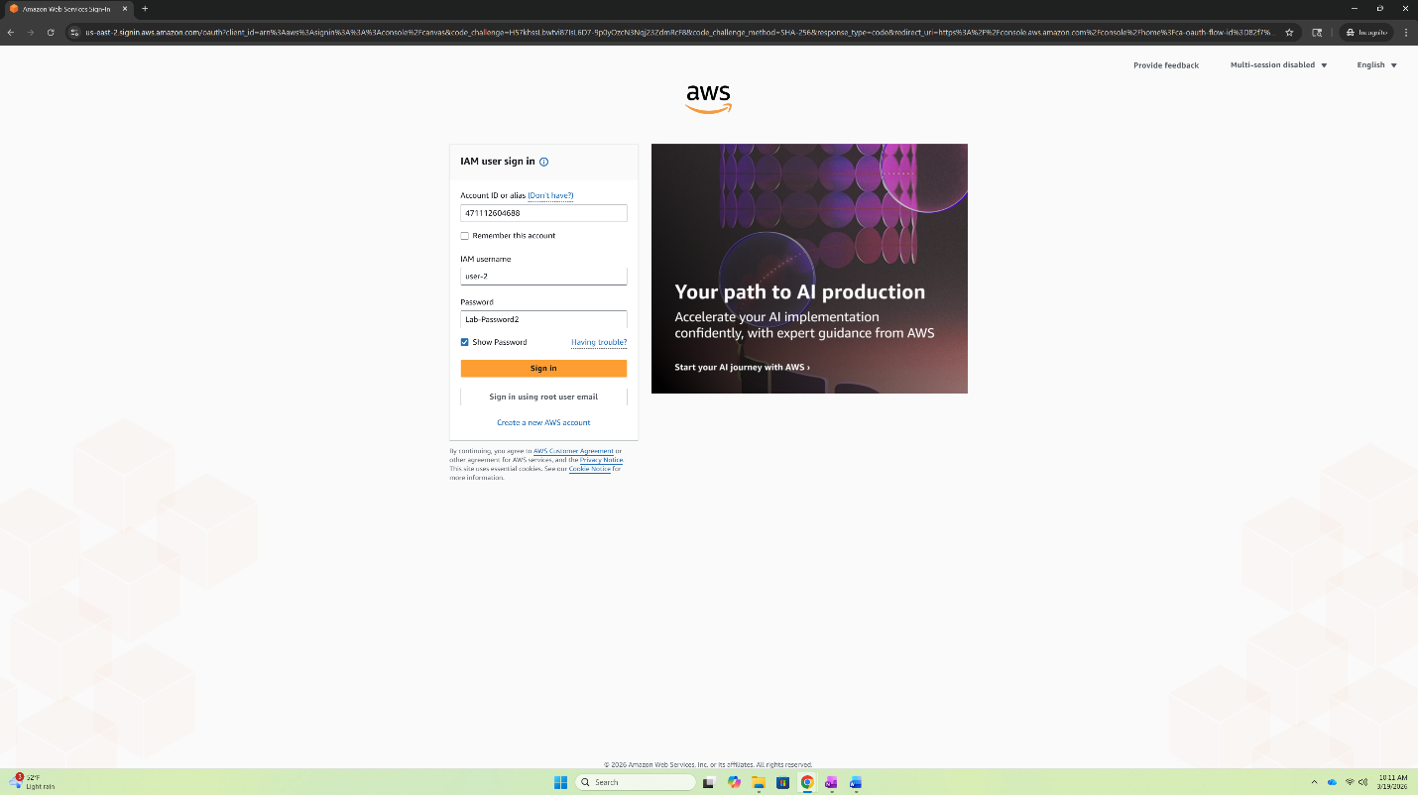
Next, log into user-2.
Here are the credentials for user-2.
IAM username: user-2
Password: Lab-Password2
Then using the same process as in user-1 and log out of user-2.

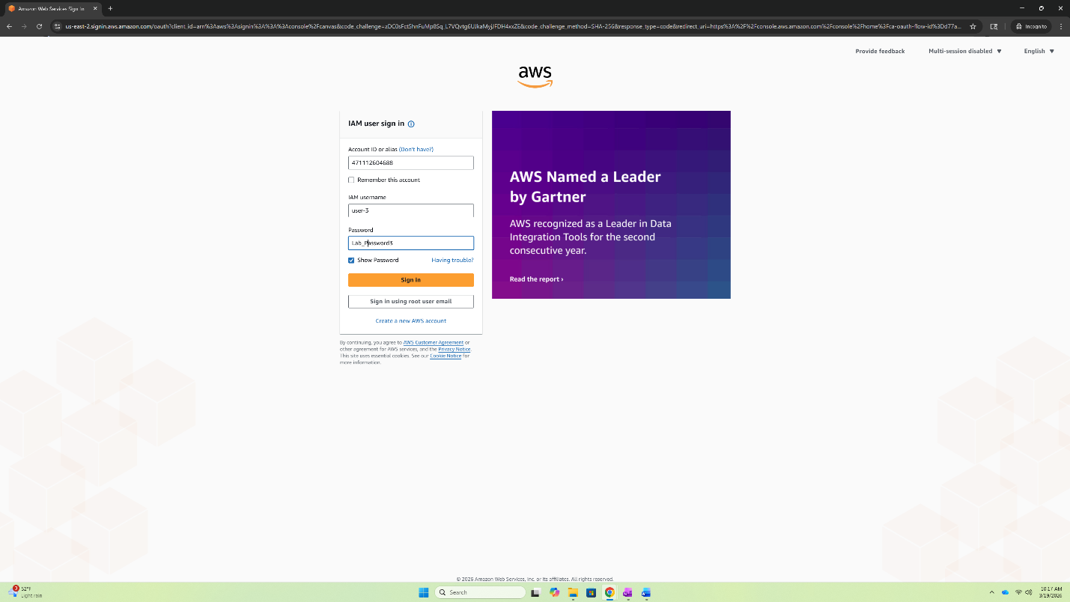
Finally log into user-3.
Here are the credentials for user-2.
IAM username: user-3
Password: Lab-Password3
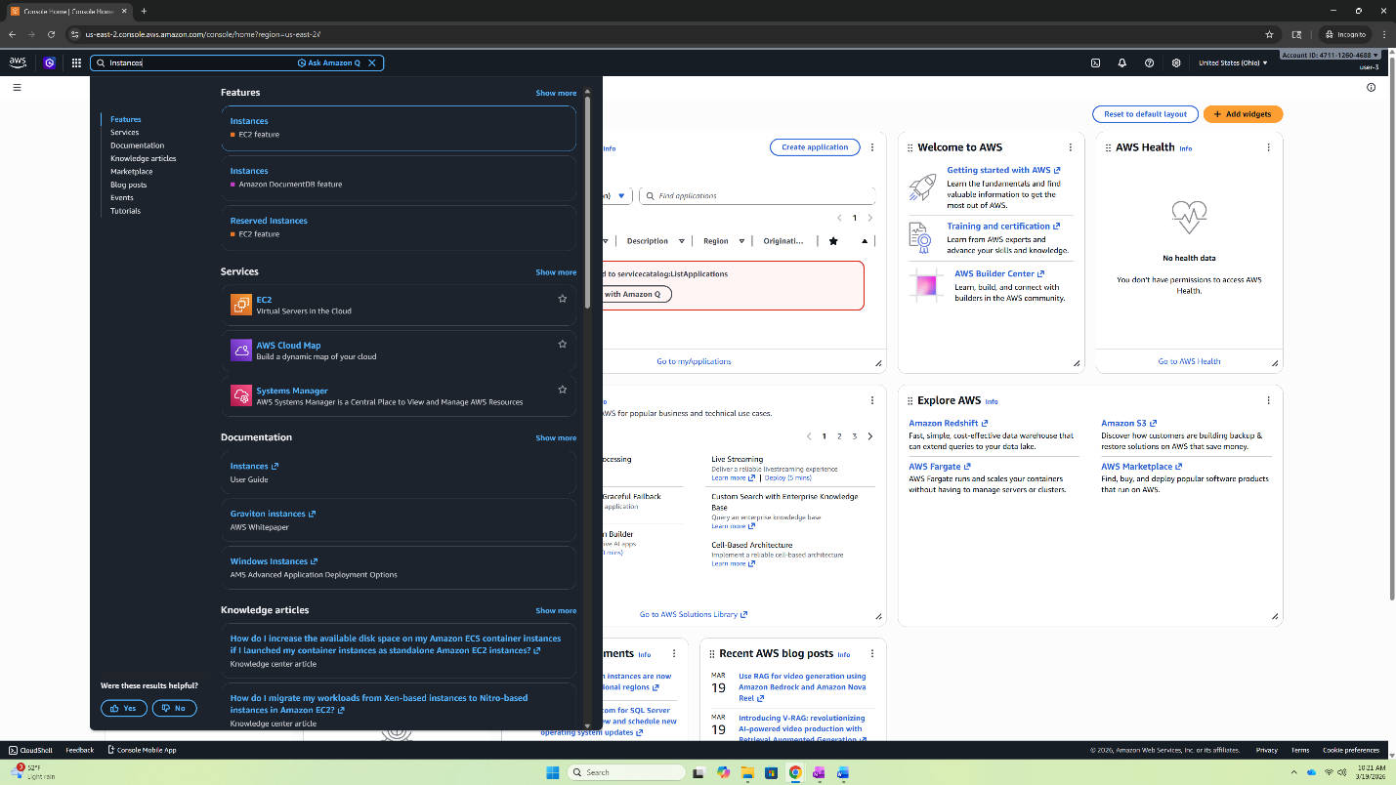
Under, user-3 search for EC2 in the search bar and click the EC2 link beside the EC2 icon.
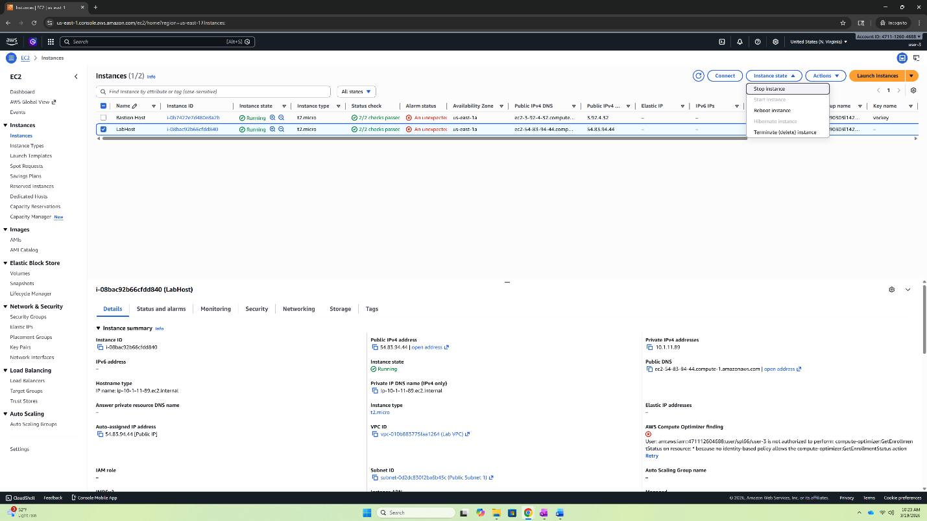
Then, click Instances in the left side bar to enter the instance menu. Next, click the checkbox beside LabHost. Finally, click the Icon for instance state and select stop instance.

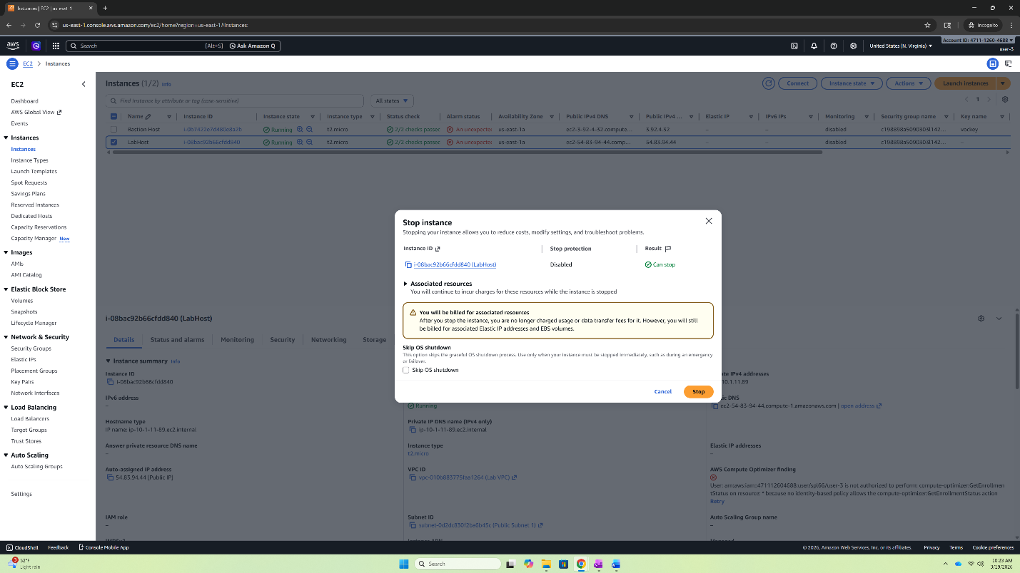
If this menu pops up, just click “Stop”.
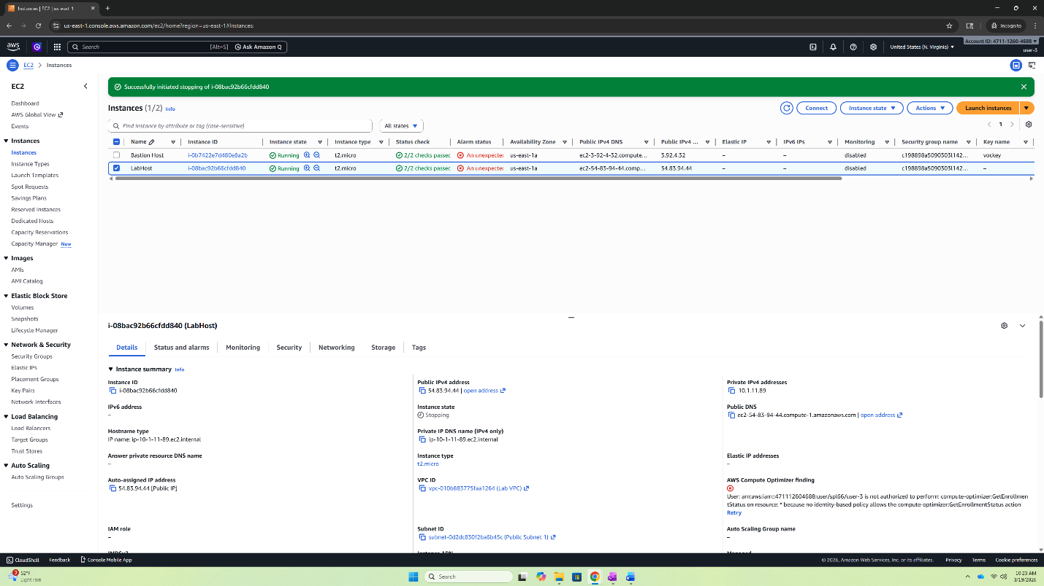
You have now successfully completed Lab 1!

Lab 2 – Build your VPC and Launch a Web Server
As expected, you should be able to navigate turning on the lab and accessing the AWS management console. Here search for VPC and select the link for VPC beside the VPC icon.
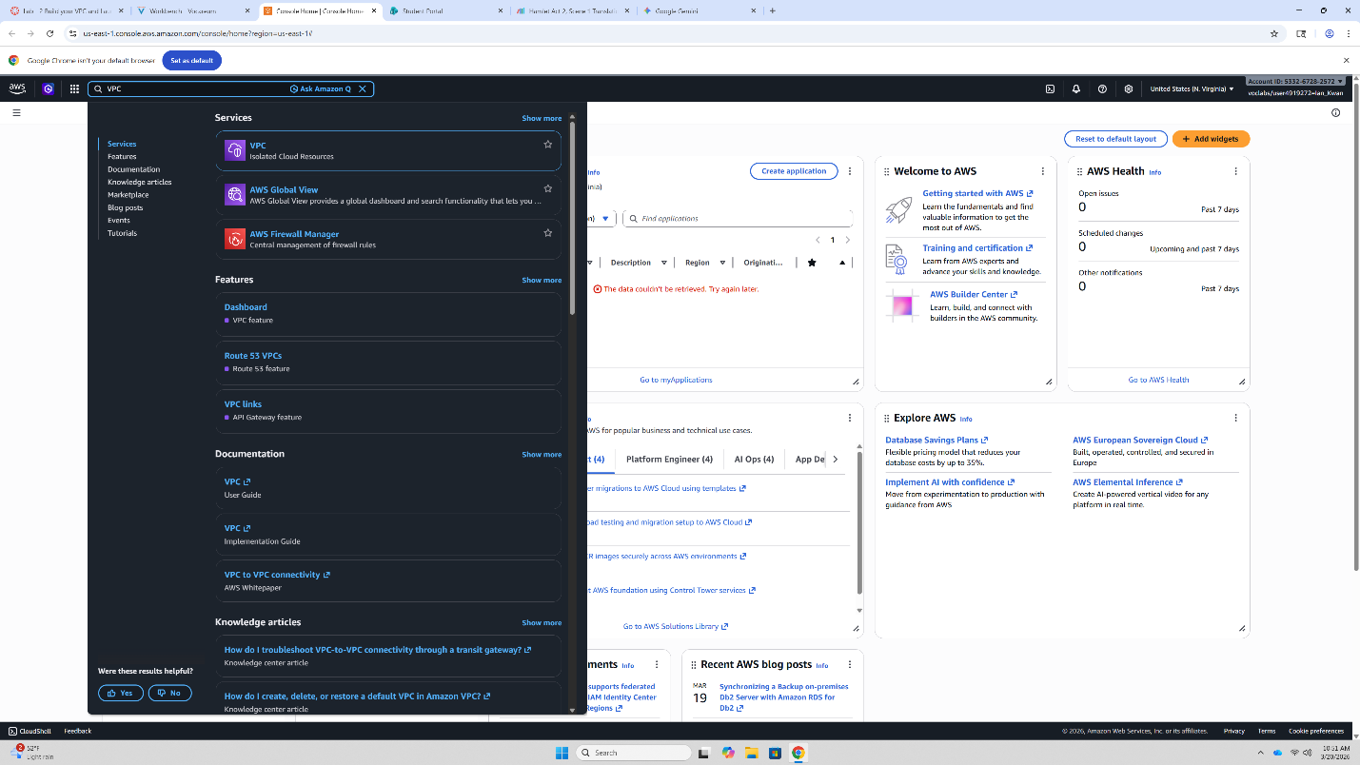
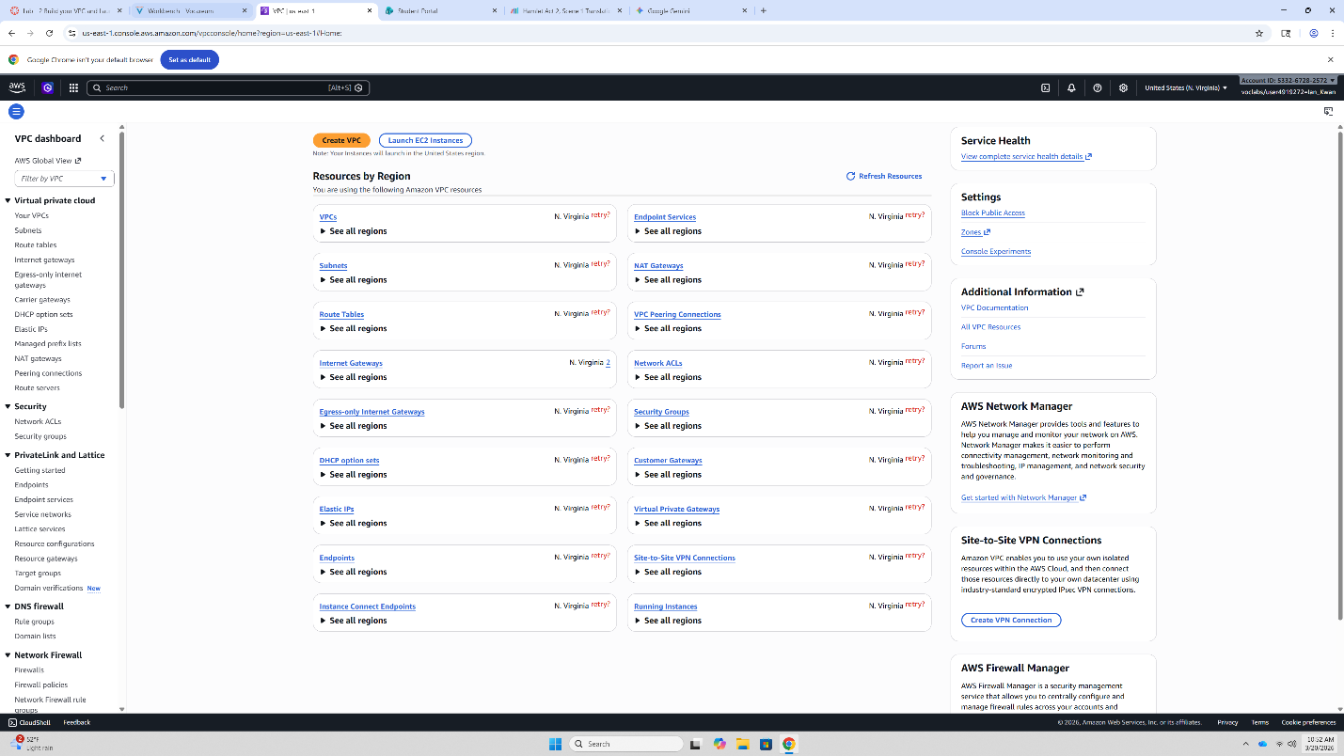
Under the VPC Dashboard, select “Create VPC”.

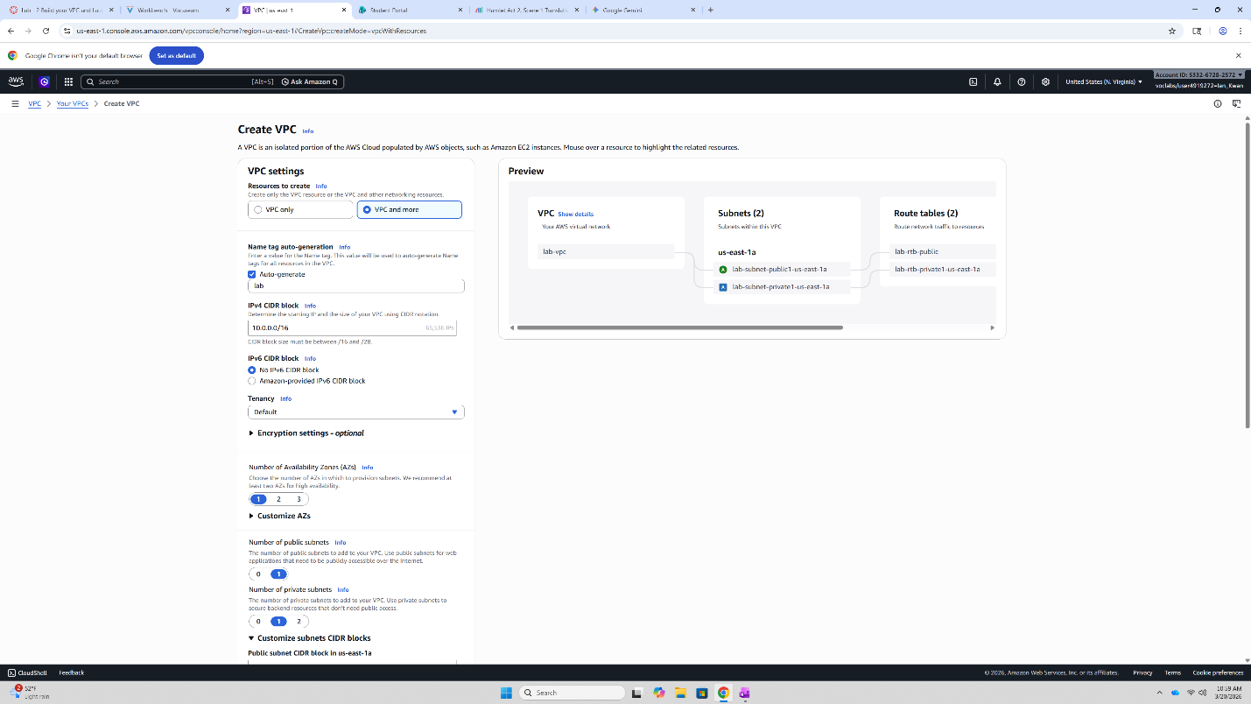

Follow these instructions very carefully.
Set the VPC settings to “VPC and More”.

Under Name tag auto-generation
Change the name from project to “lab”.

Make sure that the default configurations match the displayed configurations for the IPv4 CIDR block.

Next, change the number of Availability Zones to 1. Change the Number of public subnets to 1. Change the Number of private subnets to 1.

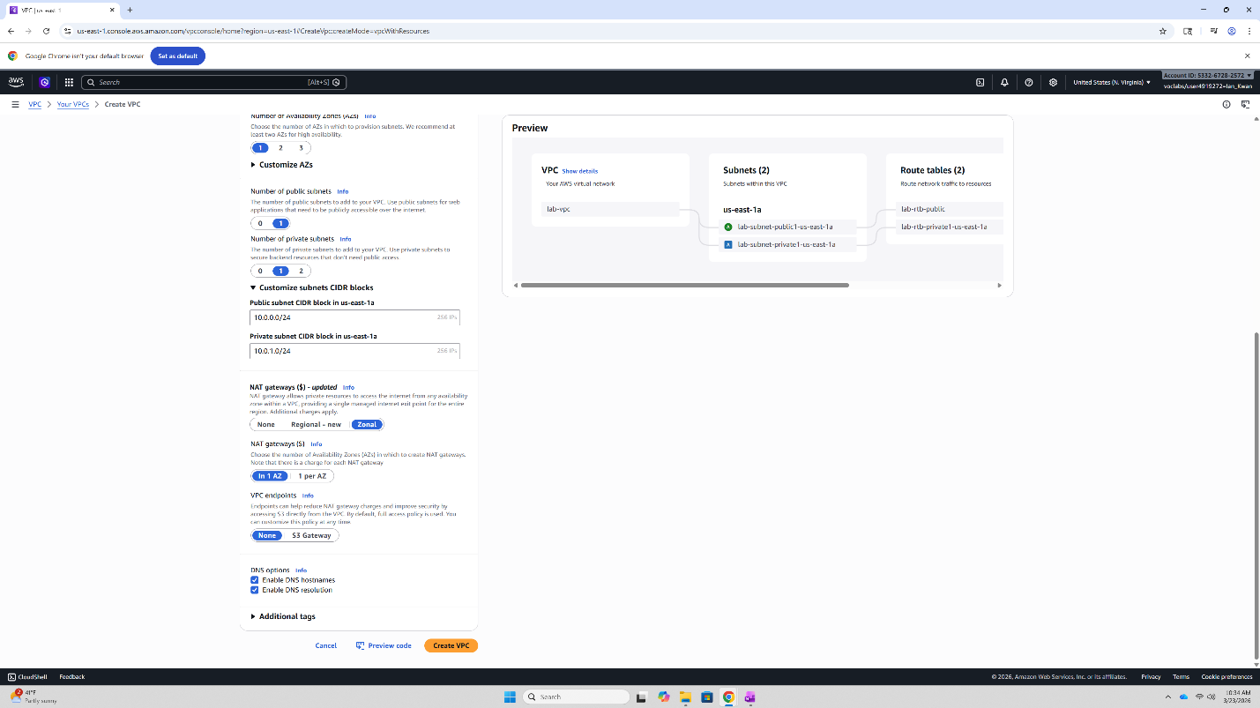
Then set the public subnet to 10.0.0.0/24 and the private subnet to 10.0.1.0/24.

Then select Zonal for NAT gateways.

Select In 1 AZ for this configuration.

And select None for the VPC endpoints.

Make sure that these DNS options are enabled.

Then select “Create VPC”.

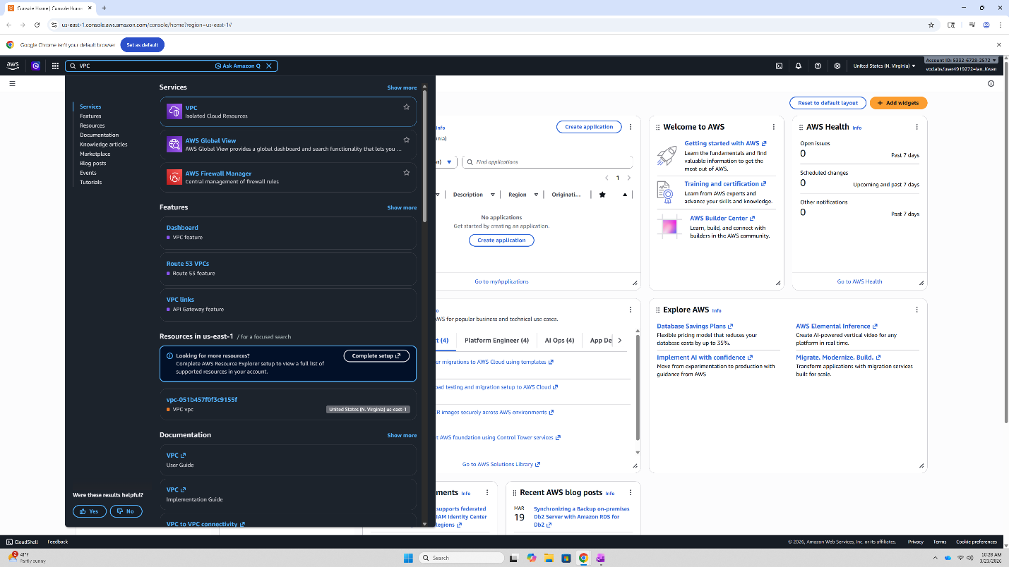
Next Navigate to the VPC service through the AWS management console.

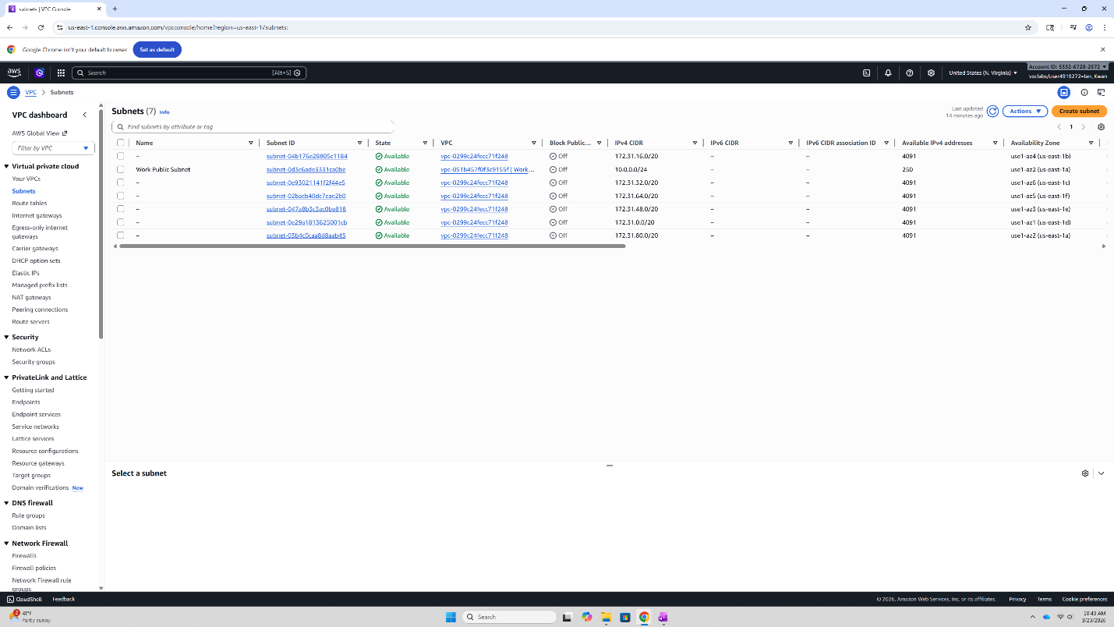
Then select Subnets in the left side bar. Then, select the “Create subnet” icon on the right in orange.

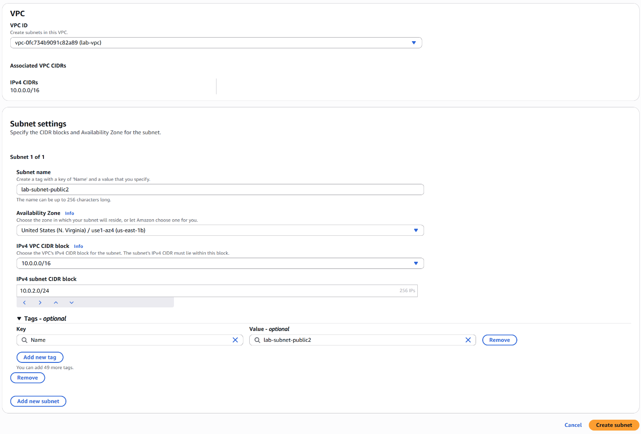
Then match the configurations shown above for the subnet.
VPC ID: lab-vpc
Subnet name: lab-subnet-public2
IPv4 CIDR block: 10.0.2.0/24
Finally, click create subnet.

After creating that subnet, click the “Create subnet” icon again to create another subnet.
Match the following configurations.
VPC ID: lab-vpc
Subnet name: lab-subnet-private2
IPv4 CIDR block: 10.0.3.0/24
Finally, click create subnet.

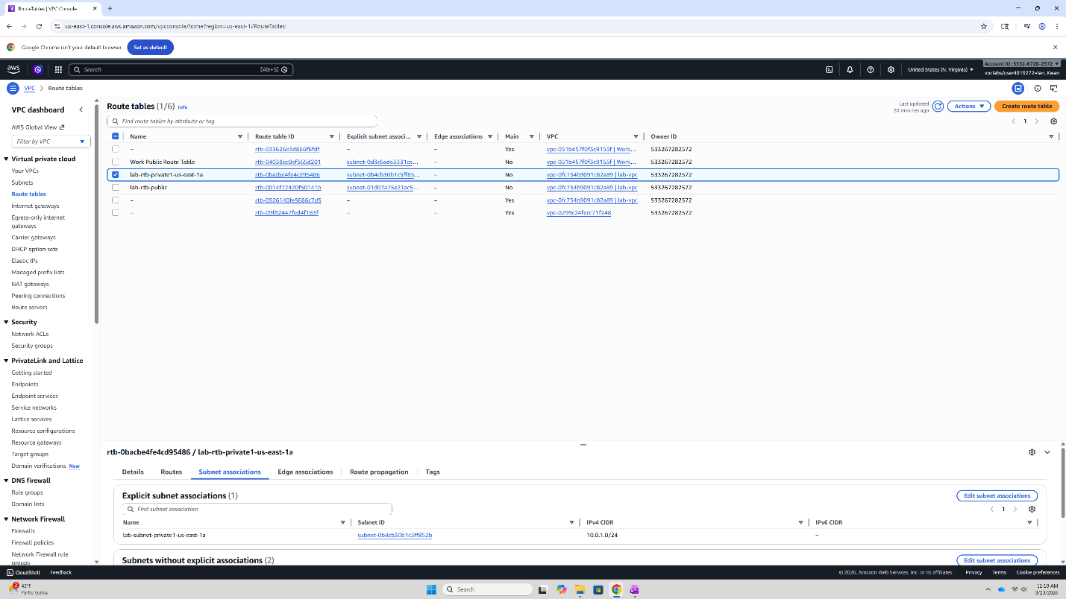
Next, navigate to the Route table menu by selecting Route table on the left side bar. Then select the check box of lab-rtb-private1-us-east-1a. At the bottom window, select the Subnet associations tab and select Edit subnet associations.

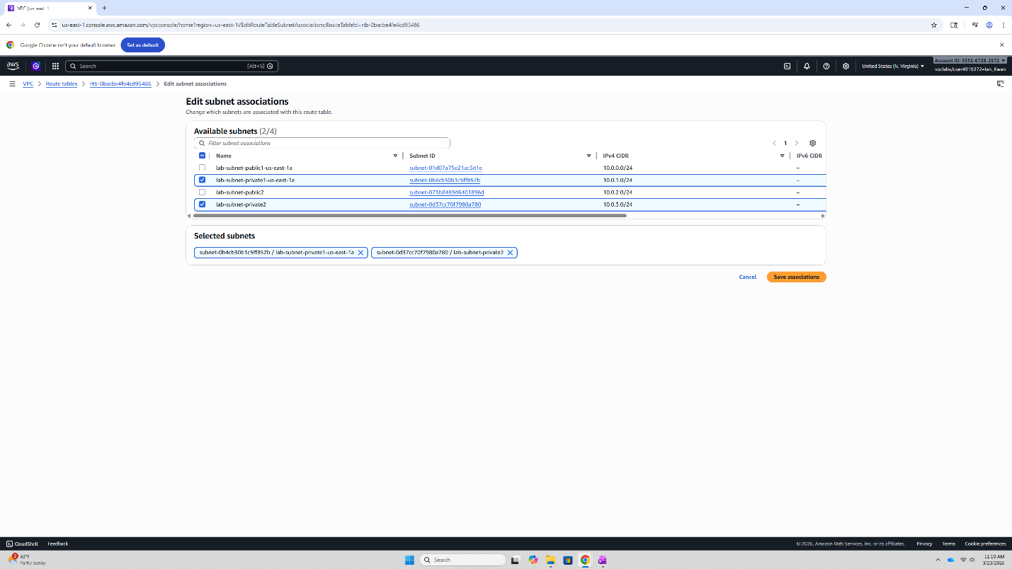
Select the checkbox of both lab-rtb-private1-us-east-1a and lab-subnet-private2. Then click save association.

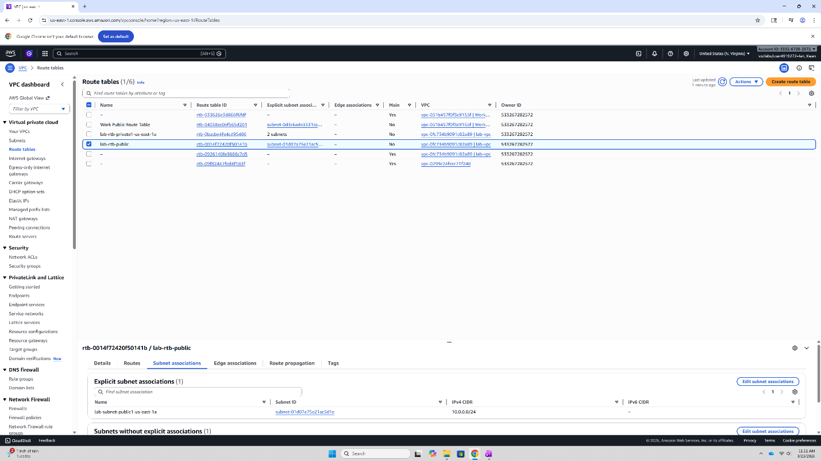Next, select the check box of lab-rtb-public and navigate to the same tab, subnet associations, at the bottom. Then select “Edit subnet associations”.

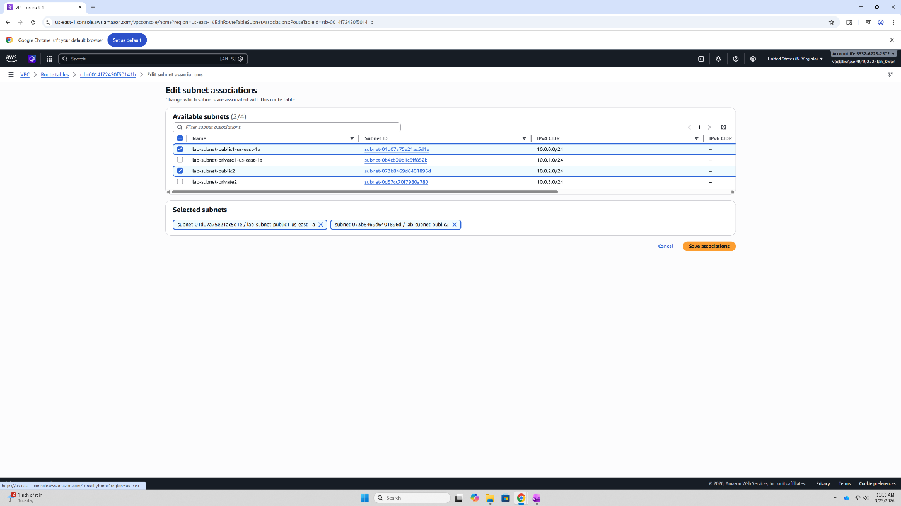
Select the checkbox of both lab-rtb-public and lab-subnet-public2. Then click save association.

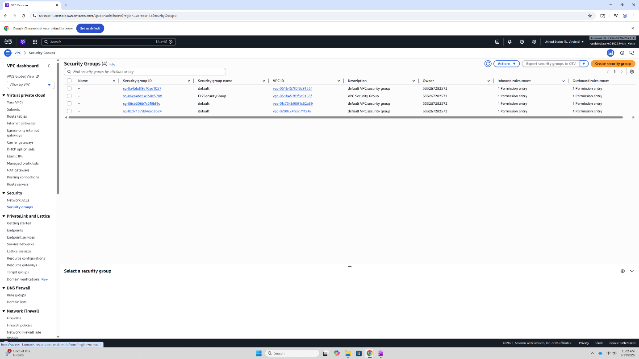
Next, navigate to Security groups on the left side bar and select the orange “Create security group” icon.

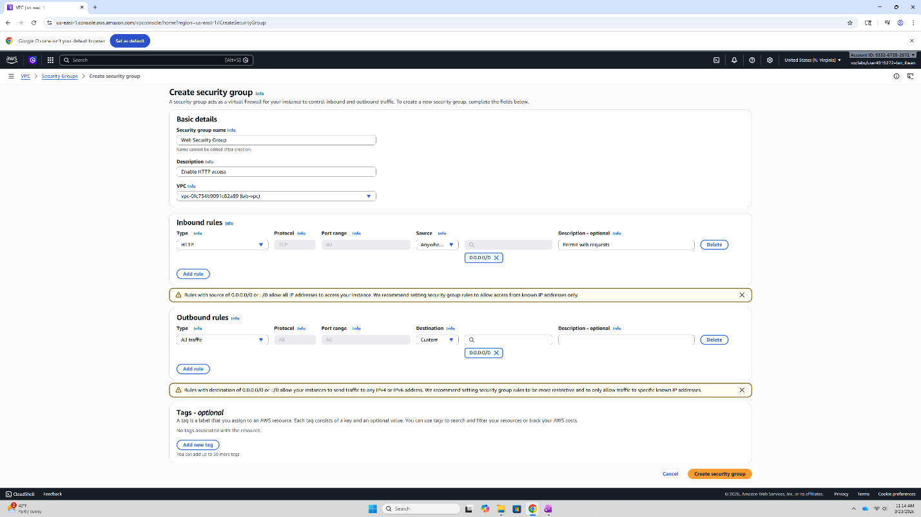
Next, match the following configurations.
Security group name: Web Security Group
Description: Enable HTTP access
VPC: lab-vpc
Under Inbound rules, select “Add rule” and match the following configurations.
Type: HTTP
Source: Anywhere-IPv4
Description: Permit web requests
Then select “Create security group”.

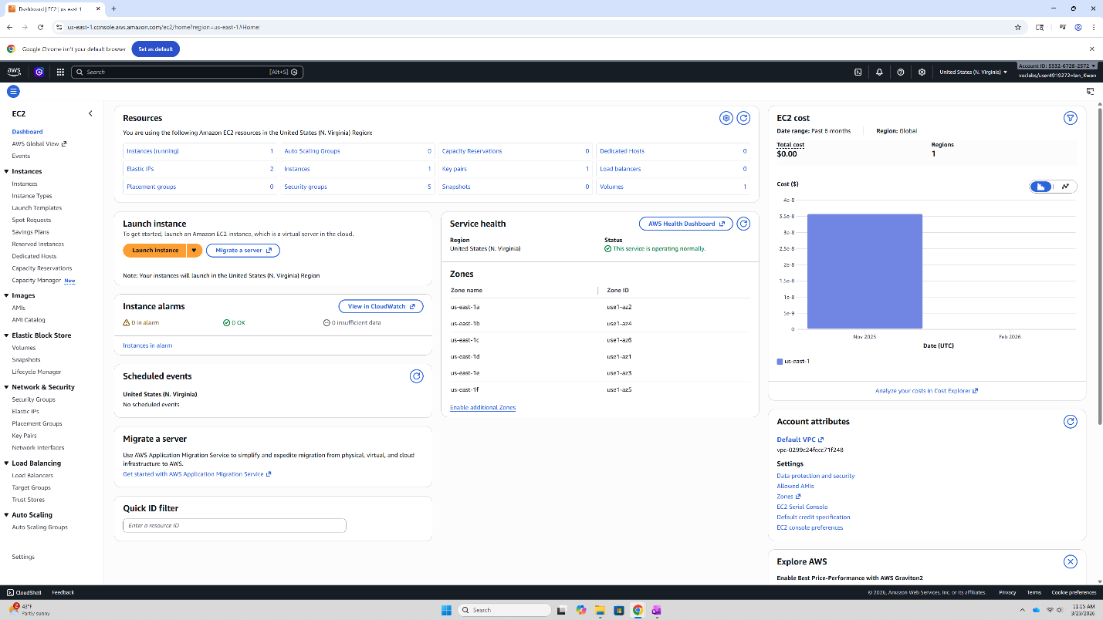
Navigate back to the EC2 menu and select “Launch instance”.

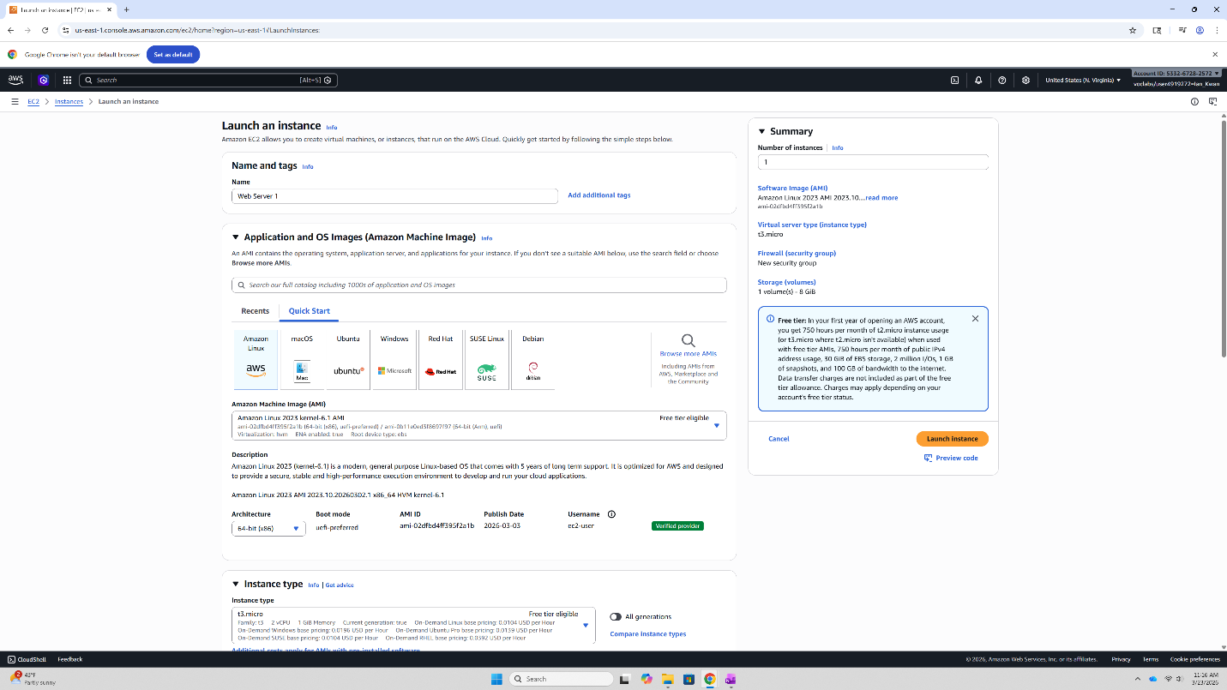
Name the instance “Web Server 1”, make sure to change the Instance type of t2.micro.

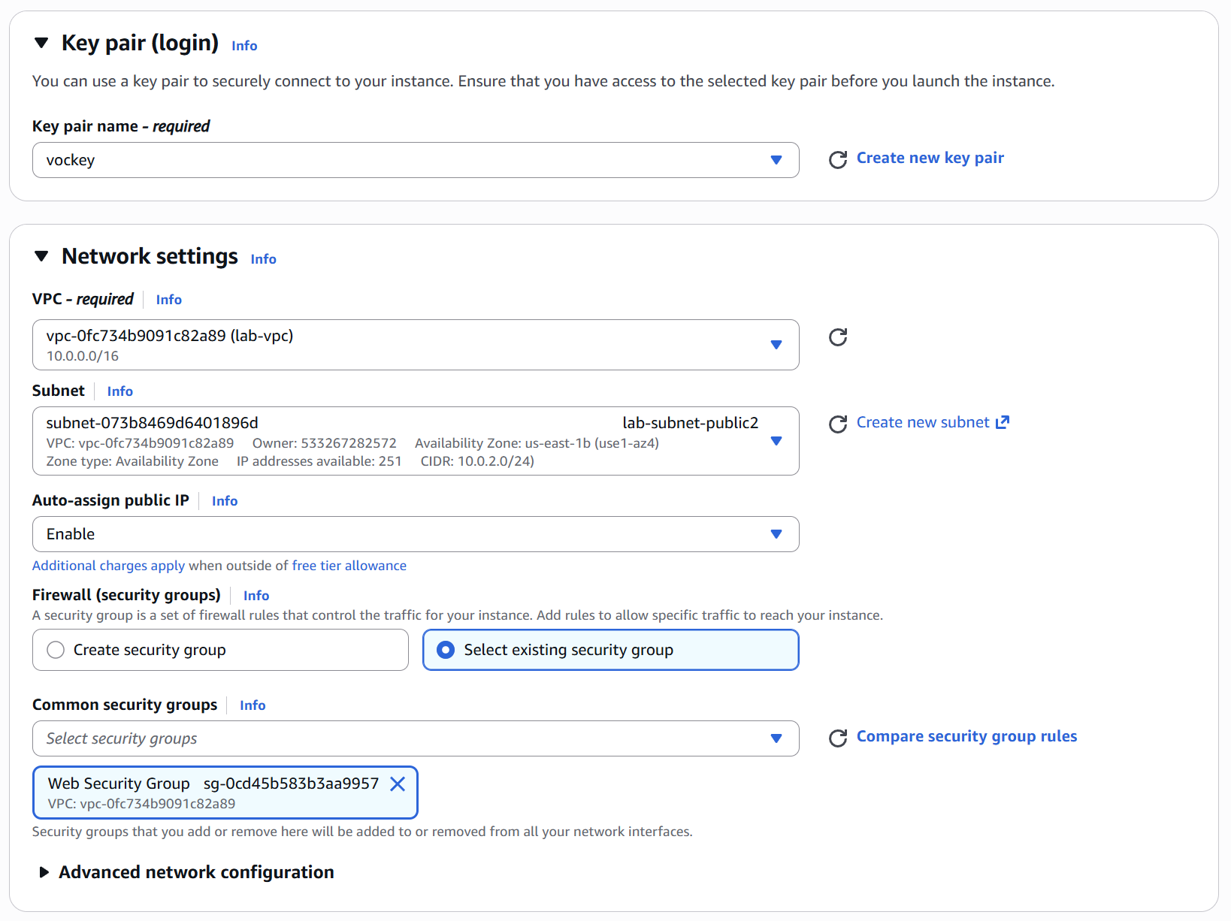Then configure the key pair name to be vockey. Select lab-vpc as the VPC. Select la-subnet-public2 as the subnet. Enable Auto-assign public IP. And select “Select existing security group” for the Firewall option. For common security groups, select Web Security Group.

Next expand the “Advanced details”.
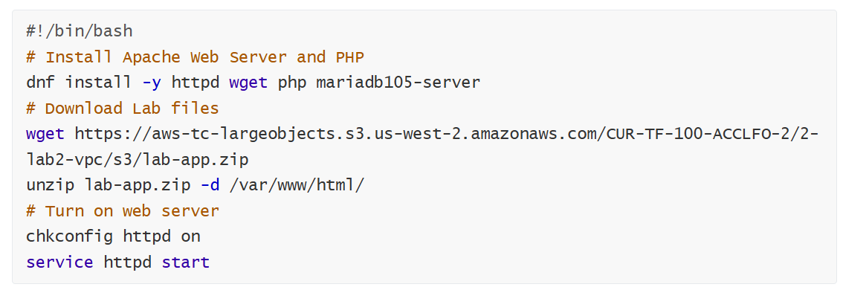
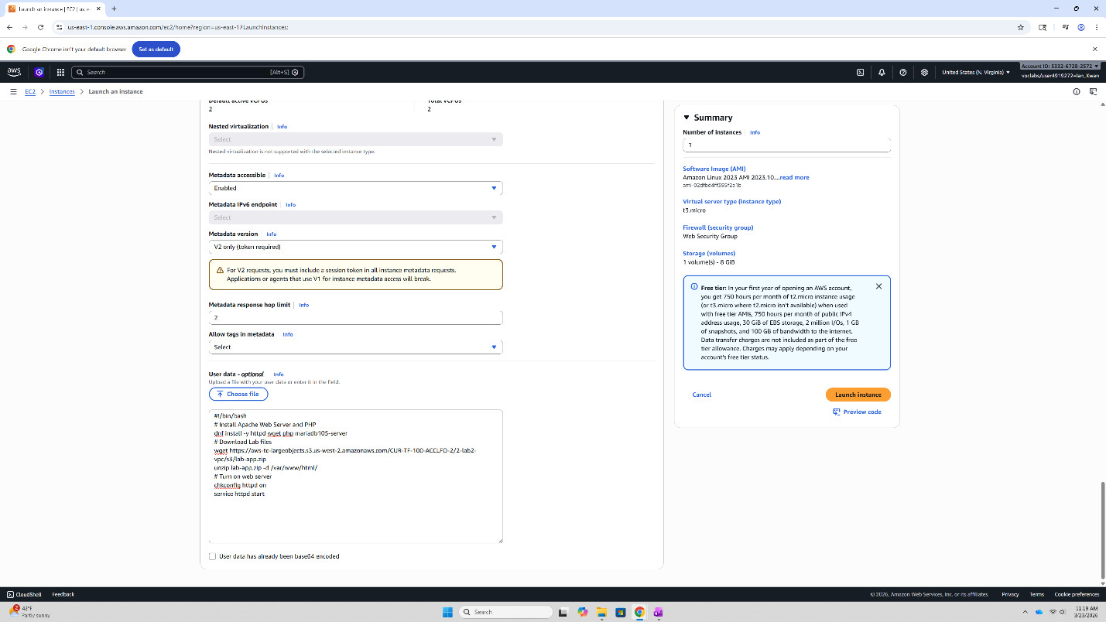
Scroll down to the User Data box and paste the above commands into the box.
Then select Launch Instance.
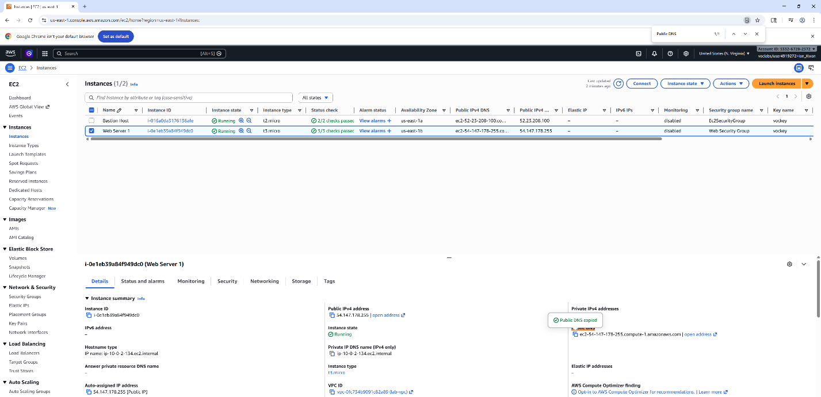
Then navigate back to Instances using the left side bar of the EC2 menu. Select the checkbox of Web Server 1. Then copy the IPv4 public DNS name. Paste this link into a new tab to see if your instance was a success. 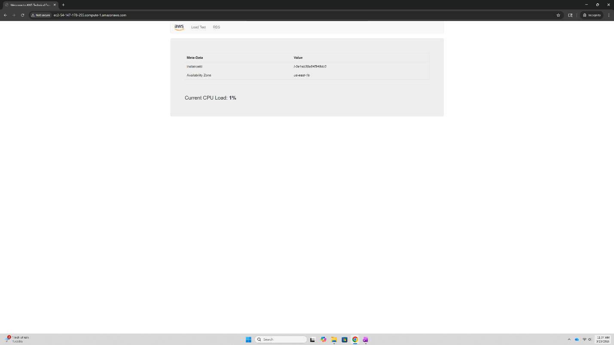
Congratulations, you completed Lab 2!

Lab 3 – Introduction to Amazon EC2
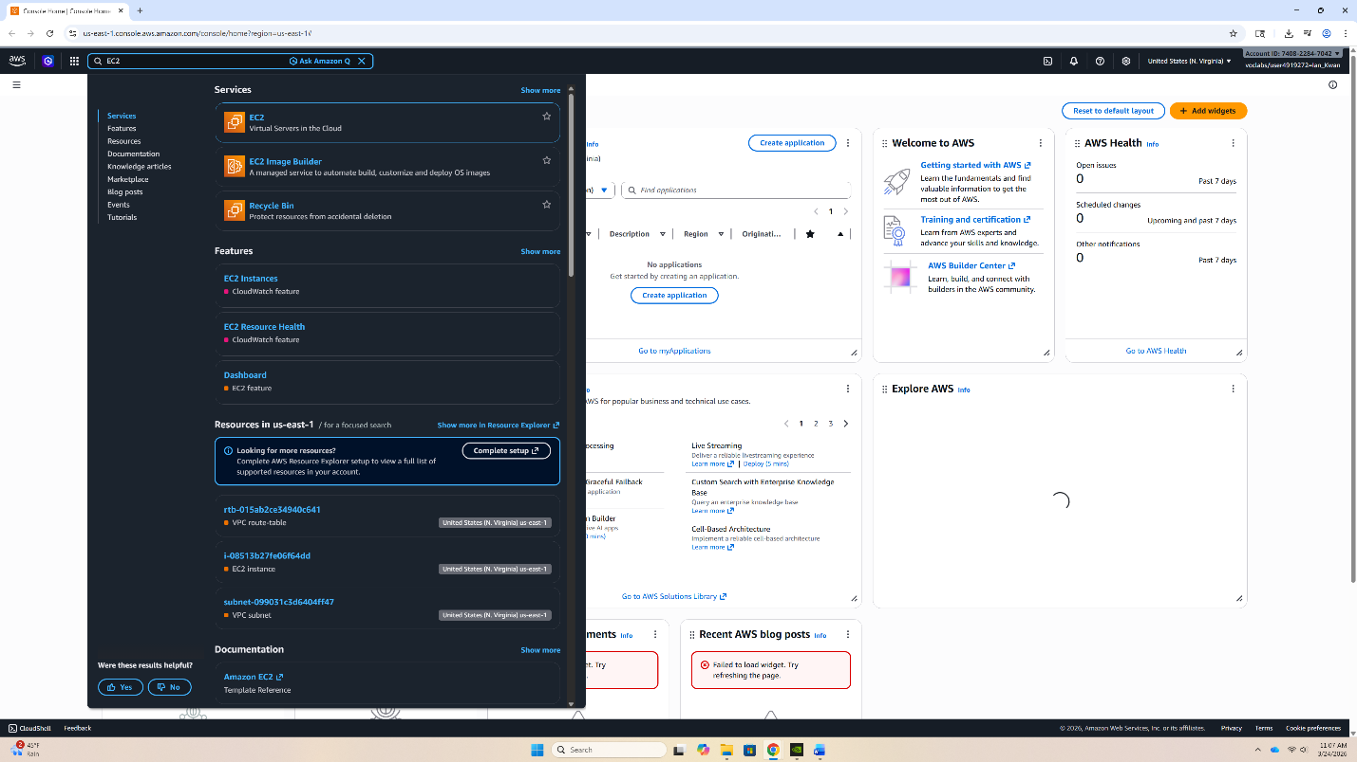
Navigate to the EC2 instance menu.
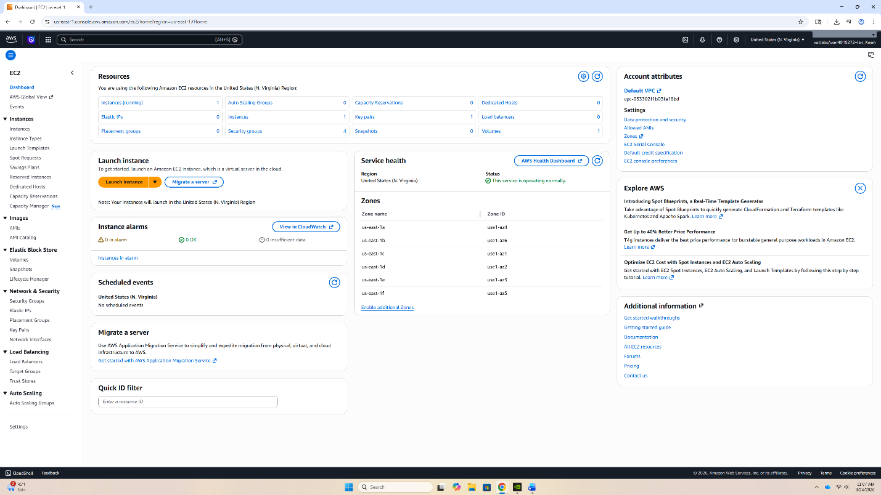
Then select Launch Instance.

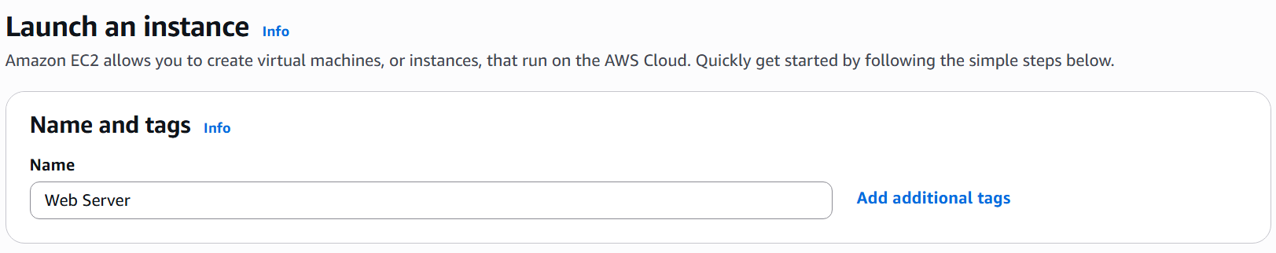
Then select the following Instance configurations.
Name: Web Server

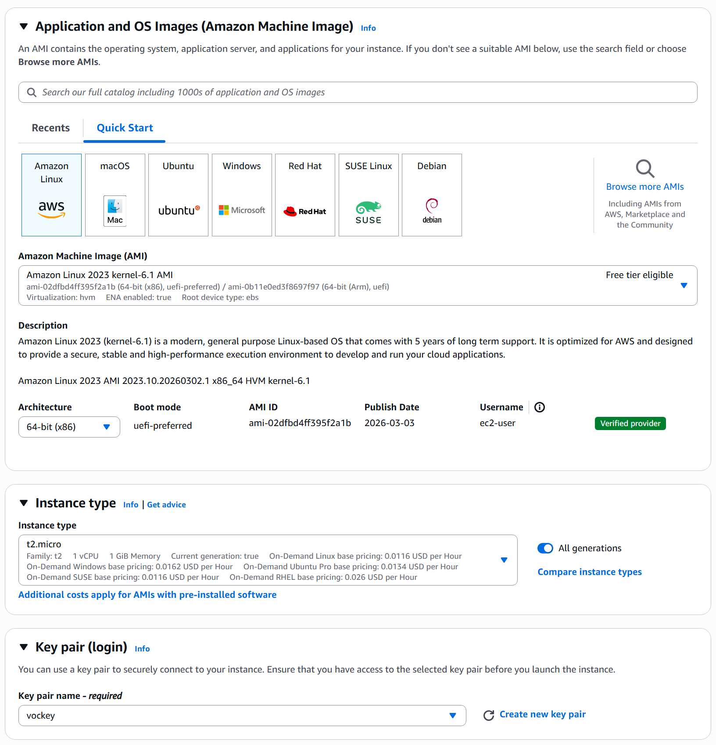
Quick Start: Amazon Linux
Amazon Machine Image (AMI): Amazon Linux 2023 kernel-6. 1 AMI
Instance type: t2.micro
Key pair: vockey

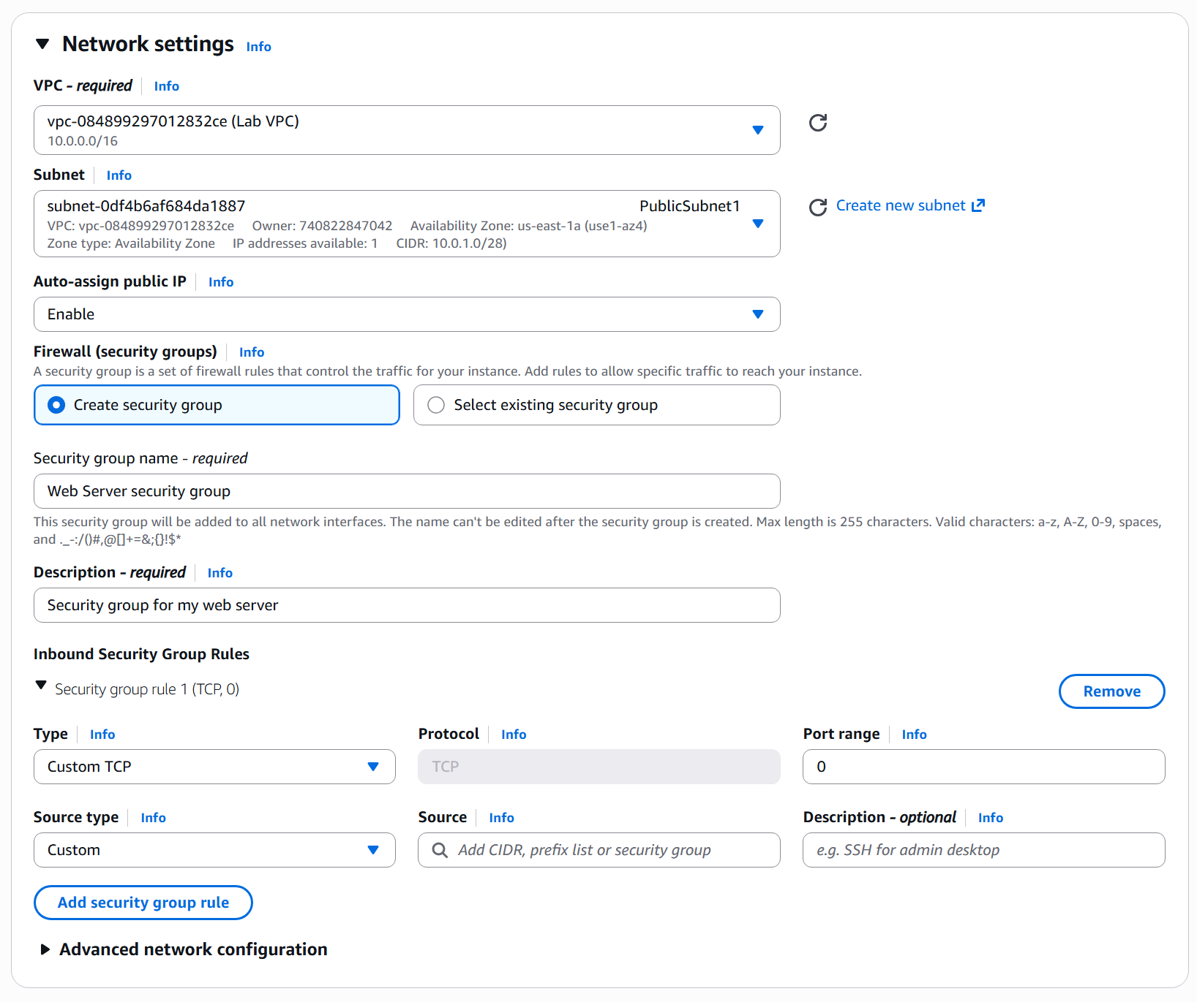
Network Settings
VPC: Lab-VPC
Subnet: PublicSubnet1
Auto-assign public IP: Enable
Firewall (security groups): Create security group
Security group name: “Web Server security group”
Description: “Security group for my web server”
Next, under Inbound Security Group Rules, click “Remove”.

Then Select “Advanced details”.

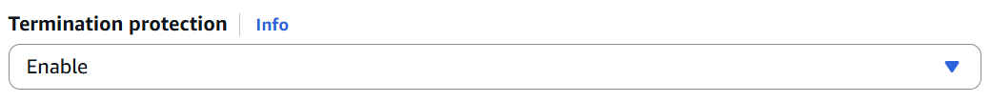
Then select “Enable” on the Termination protection.
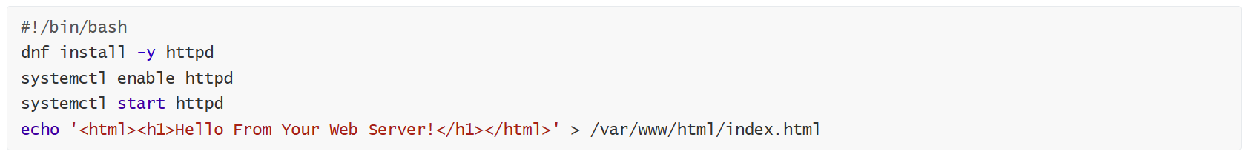
Scroll down to the User data box and paste the above commands.

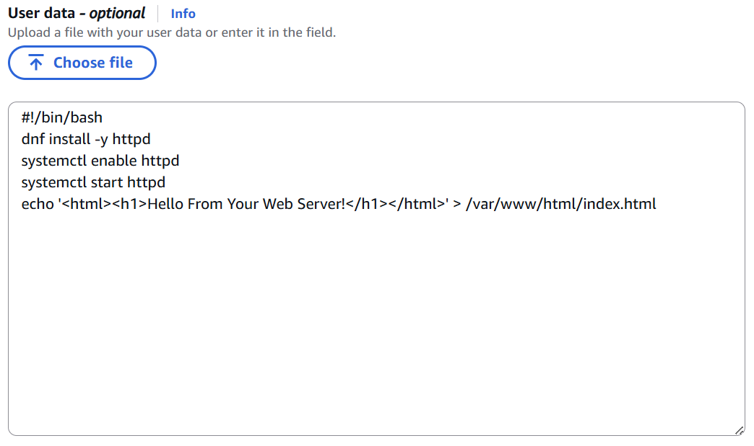
Paste the commands into the User data box.

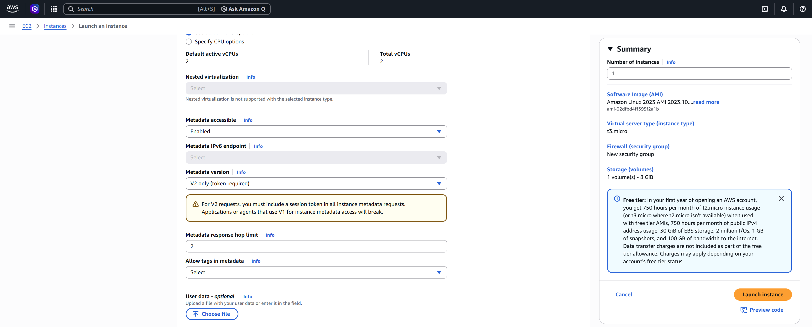
Then select, “Launch Instance”.

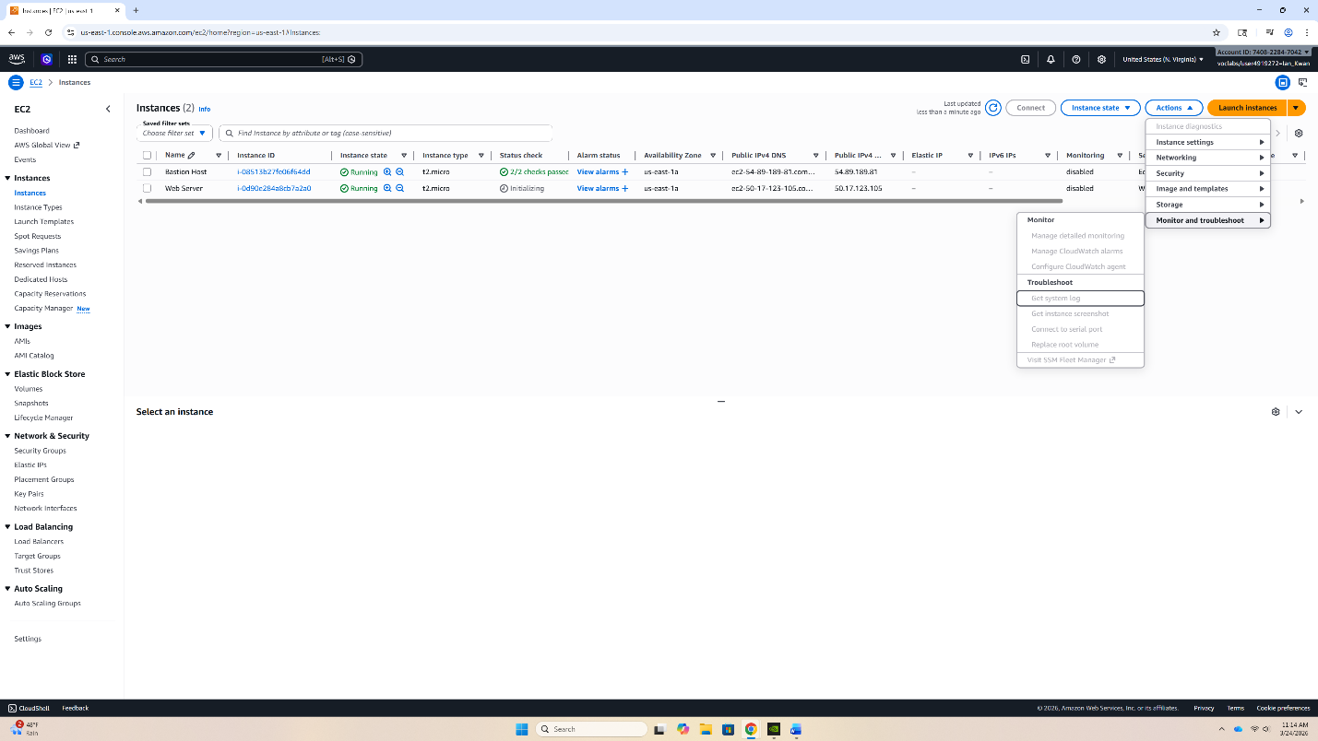
Now, we will get the system log. Under “Actions”, select “Monitor and troubleshoot”.

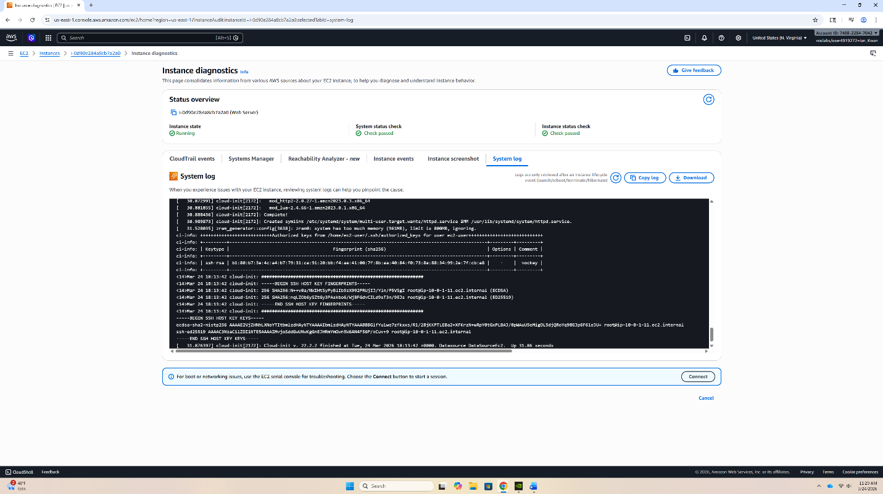
Here, explore the system log. Then select get system log. You can explore around and click “cancel” to exit.
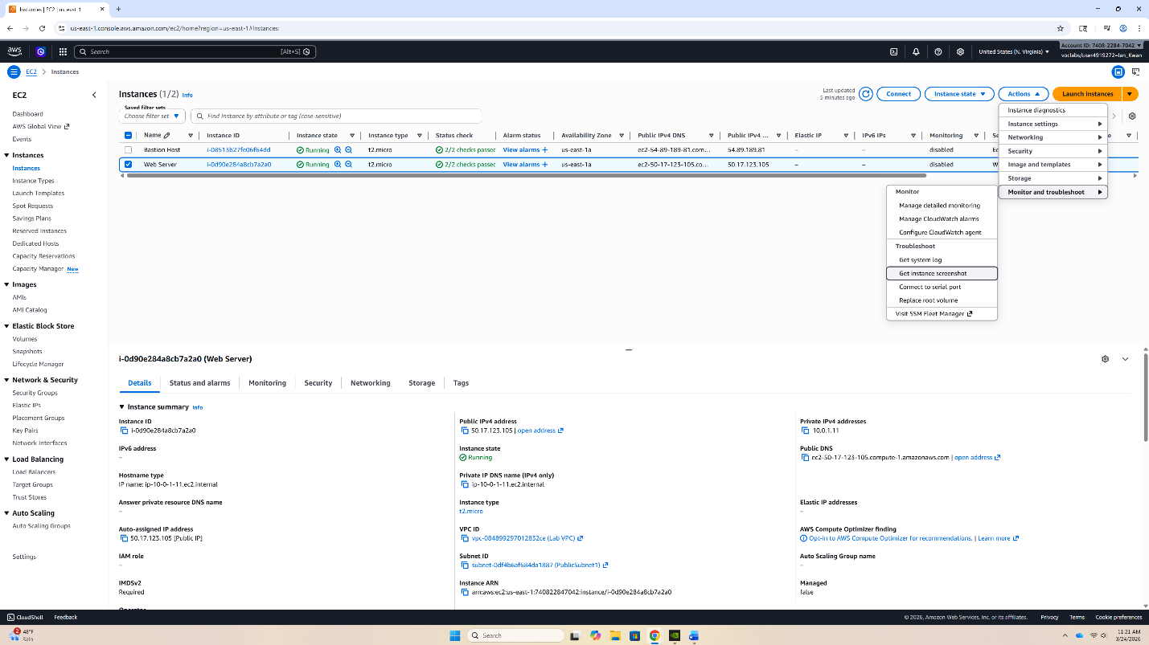
Then, using the same method, click “Get instance screenshot”. Click “cancel” to exit.

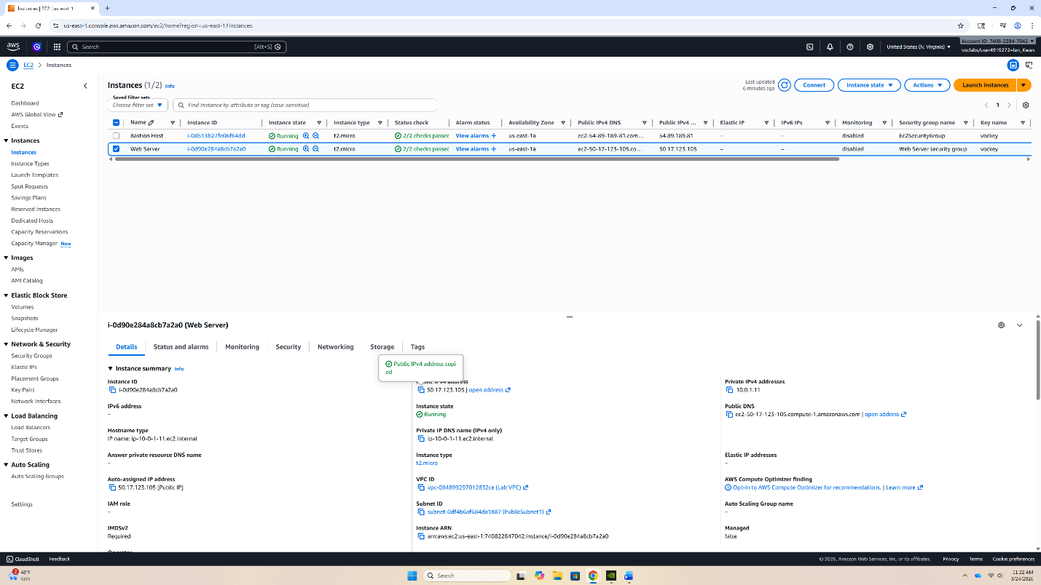
Next, copy the Public IPv4 address of Web Server. Click the copy button beside the address.

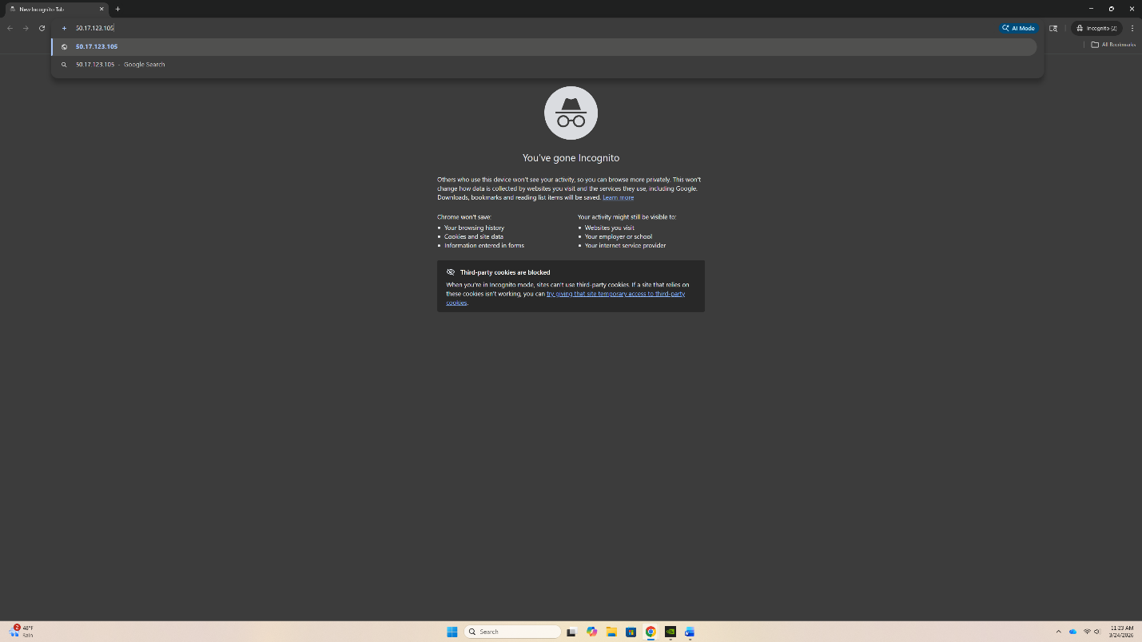
In a new window, paste the IP into the browser search window and visit the site. Because the security group doesn’t allow access through HTTP, connection is partially blocked.

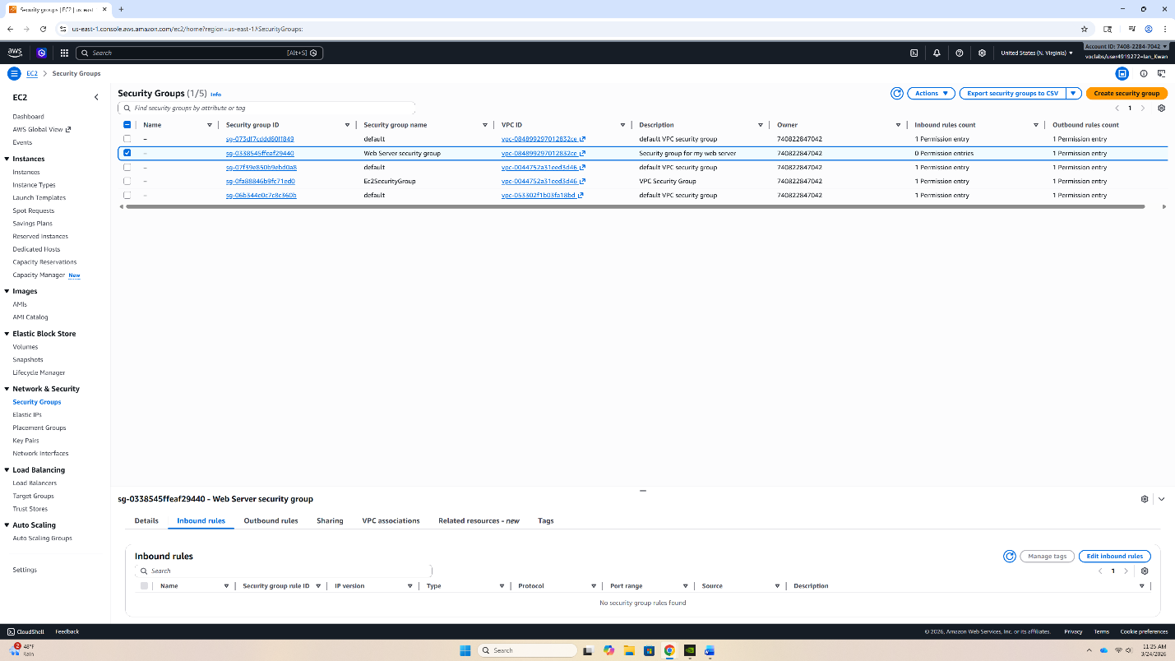
Keeping the window open, open Security Groups from the EC2 menu. Then select the checkbox next to Web Server security group. Then select “Edit inbound rules”.

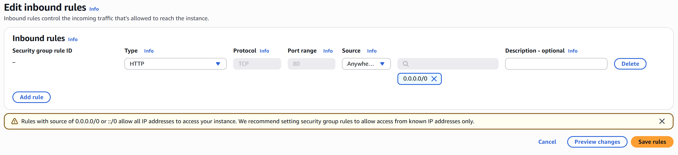
There are no rules for this security group. You must click “Add rule” and set the configuration to match the following.
Type: HTTP
Source: Anywhere IPv4
Then select “Save rules”.

Next, we are going to Resize an EBS volume.
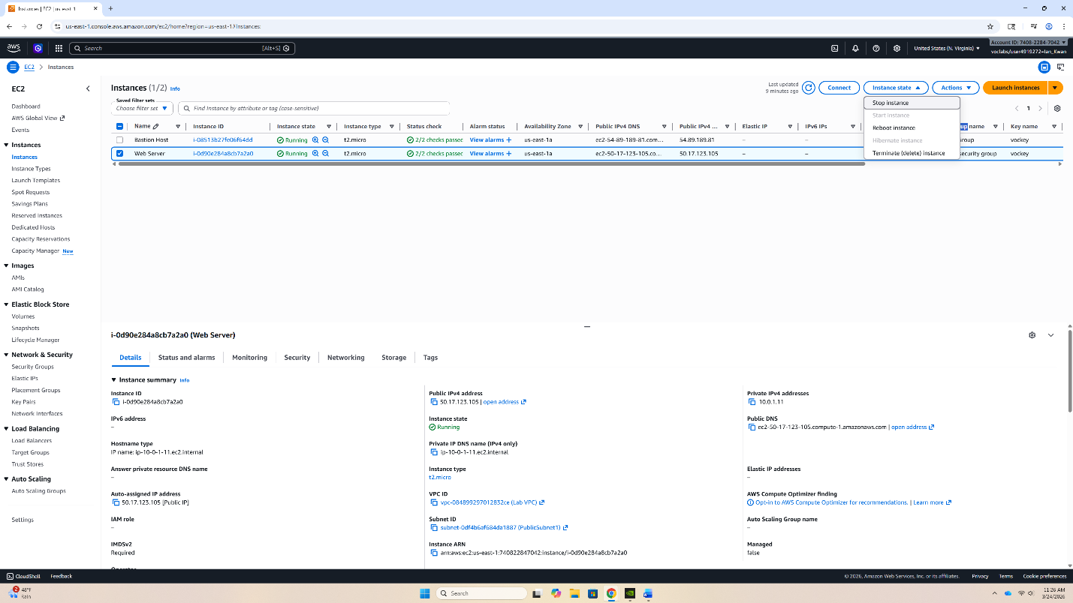
Select Instances in the left side bar. Then select the checkbox for Web Server. Then select Instance state and then Stop instance.

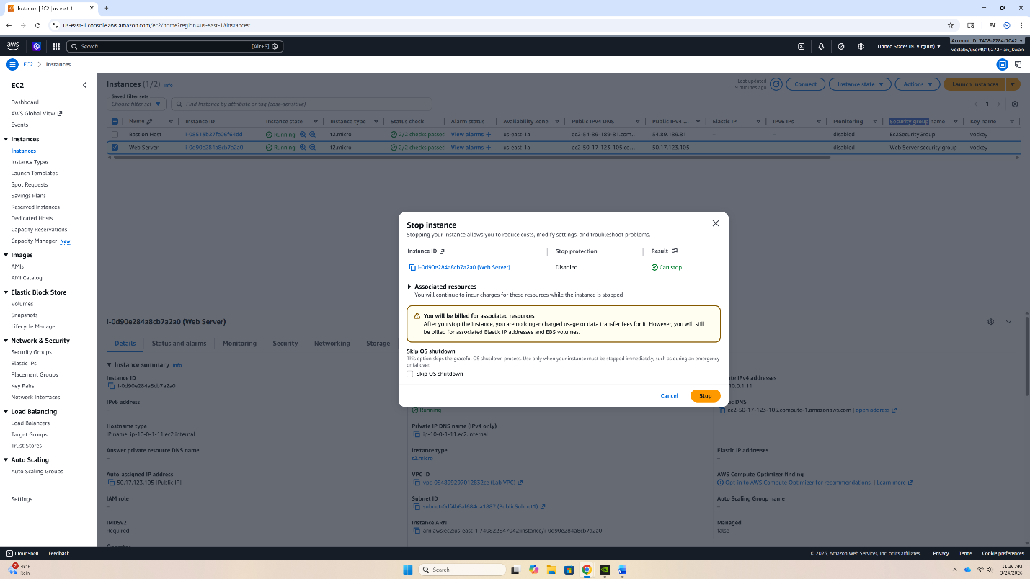
The pop up above will appear. Select “Stop”.

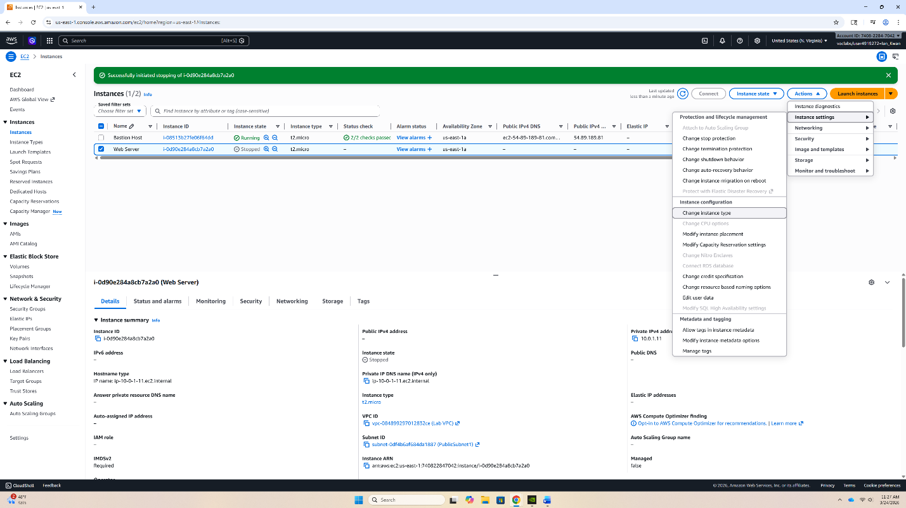
Now you can change the EBS volume. Select Actions. Then select Instance settings. Then select “Change Instance type”.

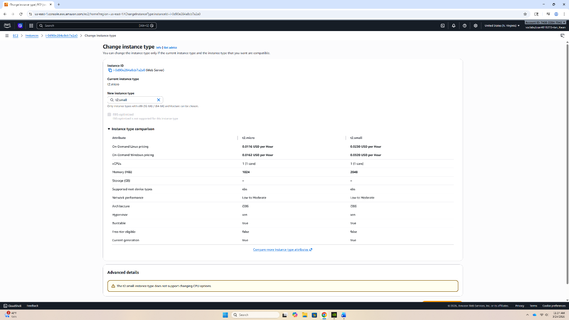
In the change instance menu, Current instance type is displayed. Under New instance type, select “t2.micro”.

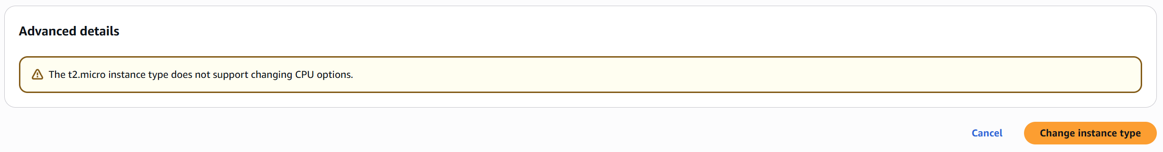
At the bottom, select “Change instance type”.

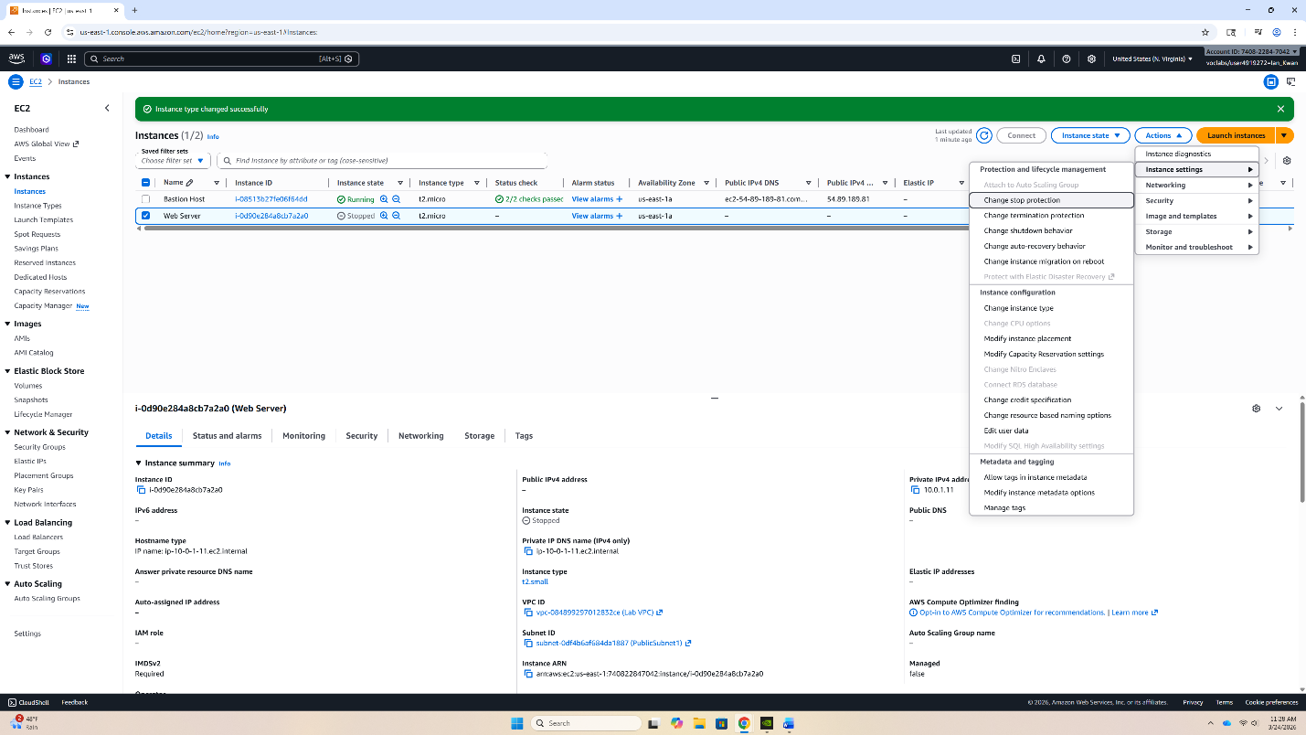
Now, we must change the stop protection. Under Actions, then under Instance settings, click “Change stop protection”.

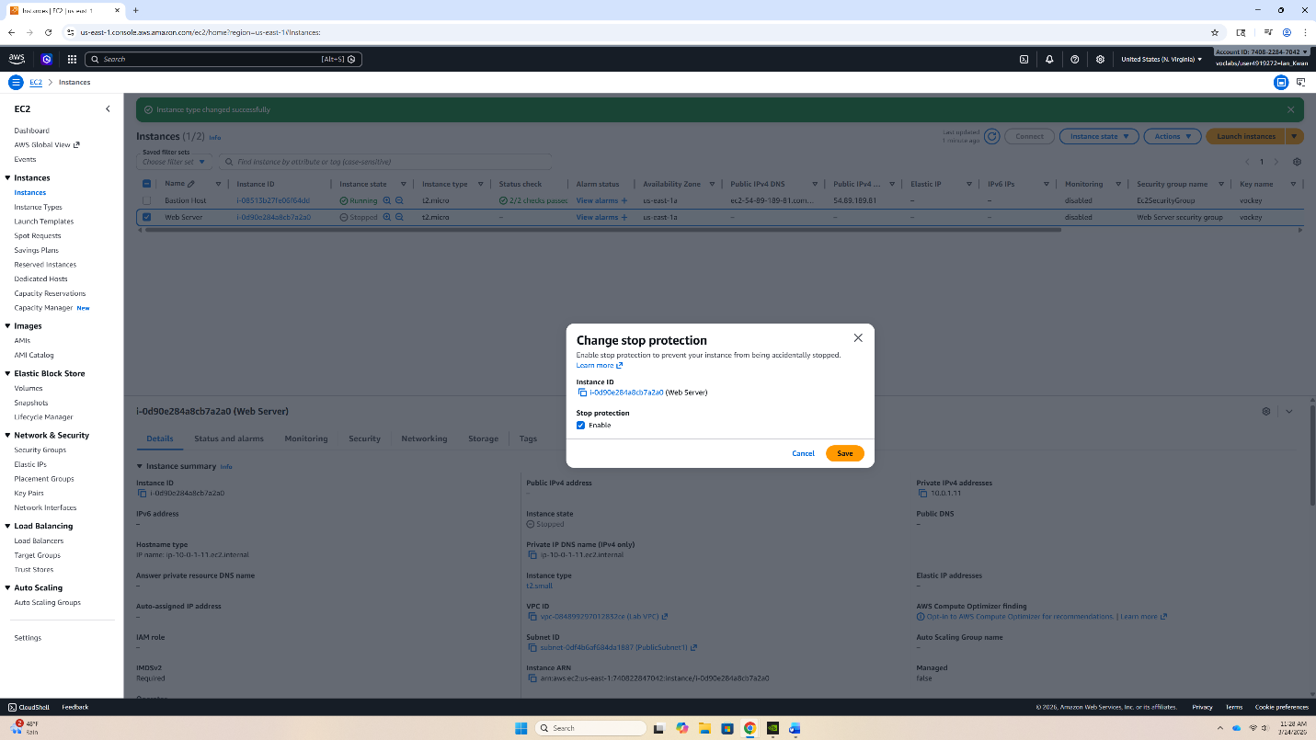
Enable stop protection by selecting the checkbox for Enable and the clicking Save.

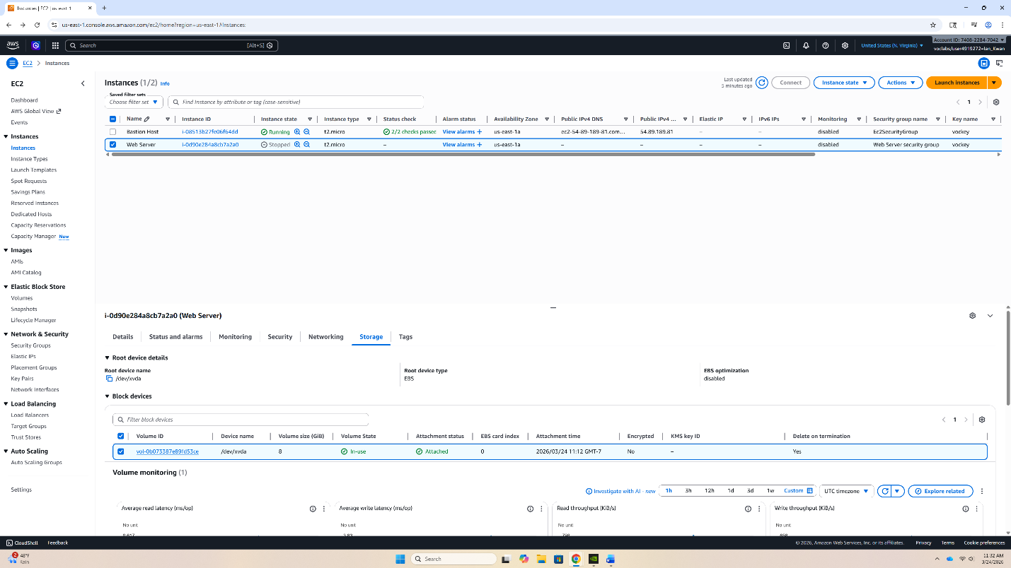
Now, we can modify the volume. Select the checkbox next to Web Server. Then open the Storage tab. Then select the link to the volume.

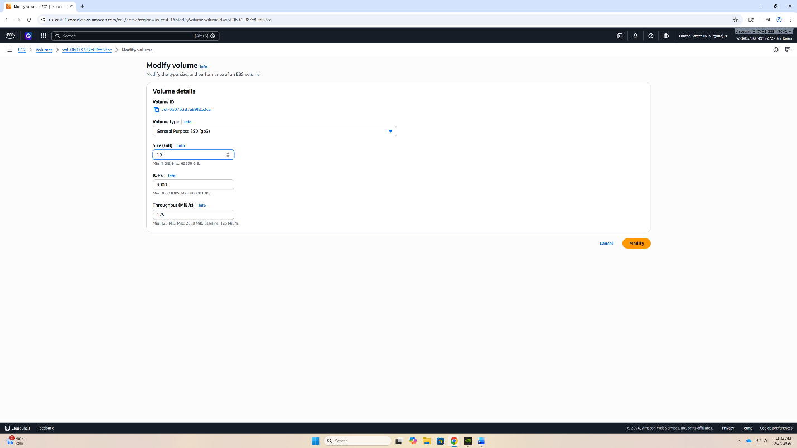
Under the Modify volume menu, change the size from 8 to 10 GiB. Then select Modify.

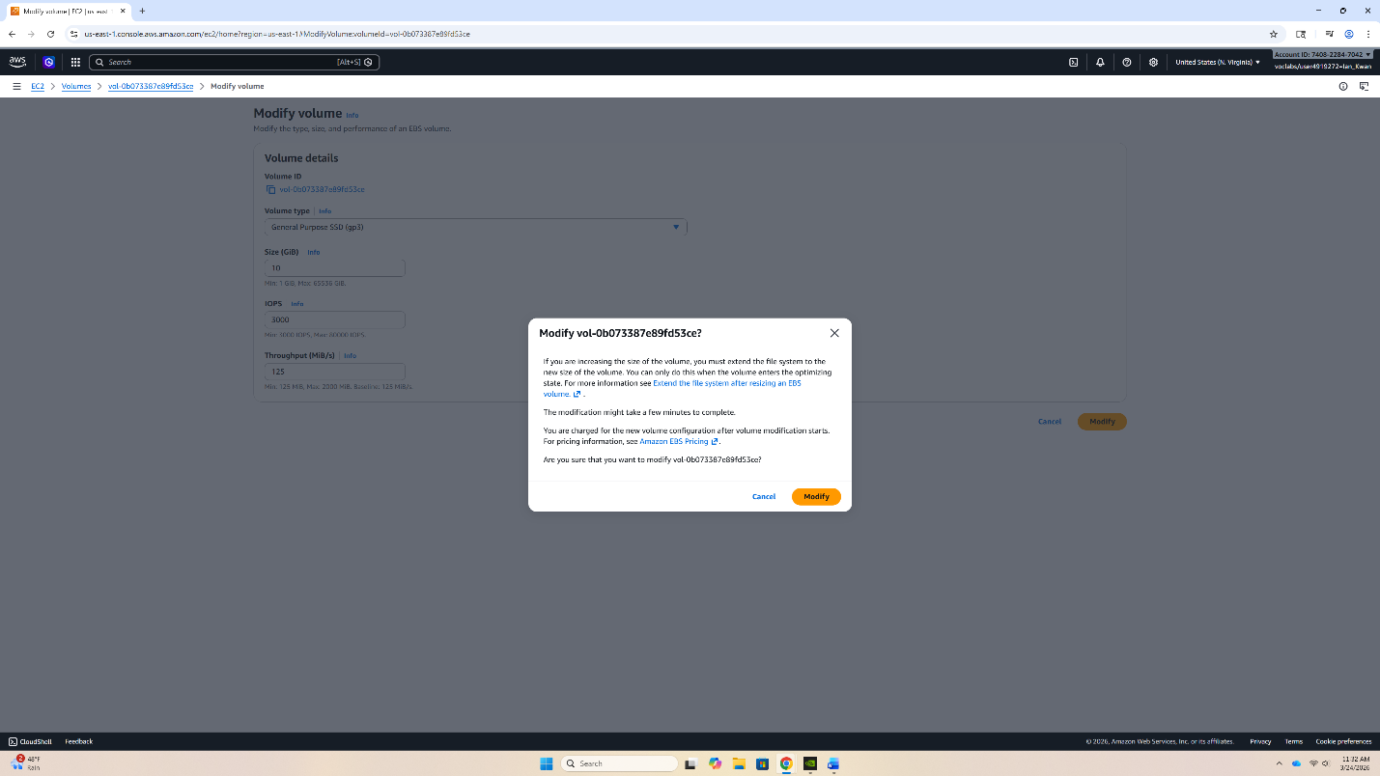
Select Modify again.

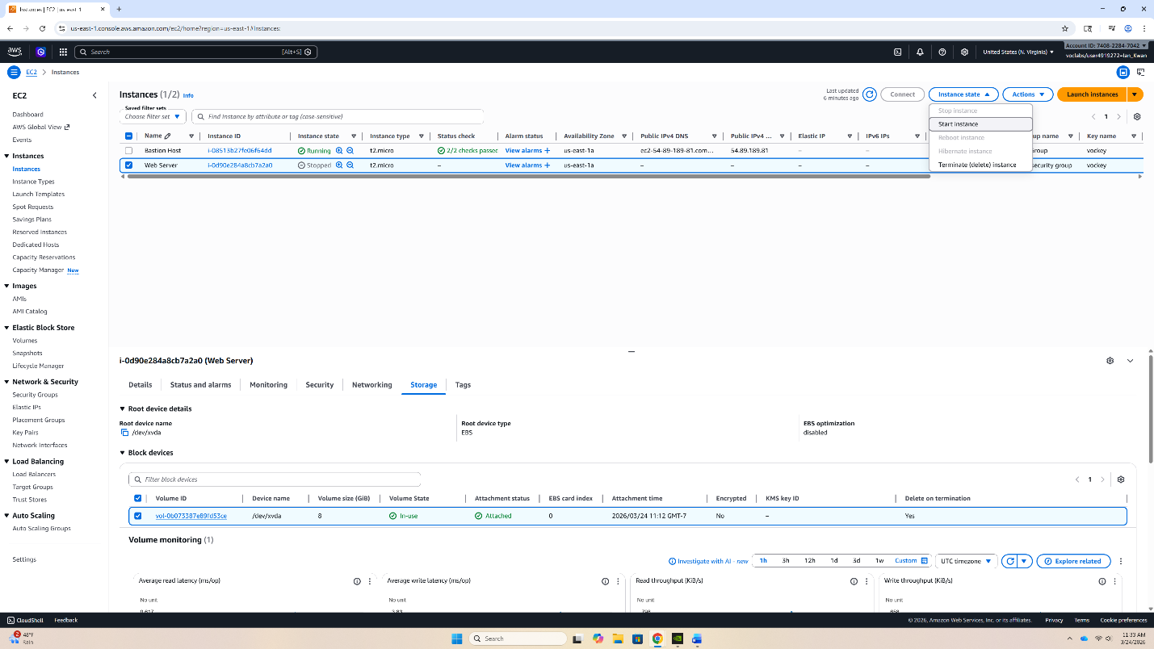
Now, start up the instance again with the modified volume. Click the Web Server checkbox. Select Instance state, the click Start Instance.


Now test if you can stop the instance. Click the Web Server checkbox. Select Instance state and click stop instance.

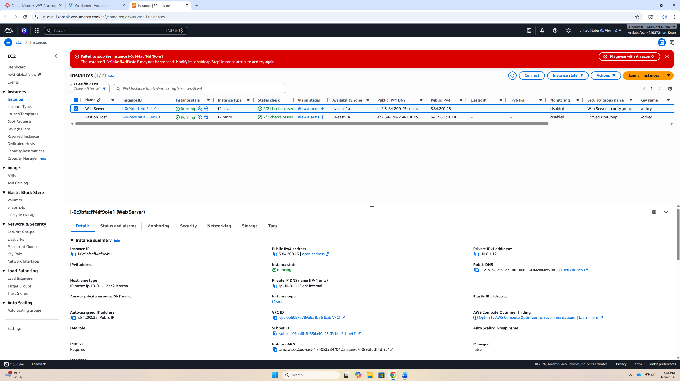
It should fail, proving that stop protection is active. Congratulations on your completion of Lab 3!

Problems
Lab 1
In Lab 1, I encountered trouble logging into user-3. The credentials were user-3 for the username and Lab-Password3 for the password. When I tried to address the problem, I retyped the credentials multiple times which did not seem to work. I also thought internet connection was also an issue, so I reconnected to a stable internet. Finally, I addressed the issue by simply reloading the page and reentering the credentials. Another possible solution is to restart the lab and try logging in again after restarting.
Lab 2
When creating the VPC, I made multiple mistakes while configuring the VPC. One key thing was that for the volume type I selected t3.micro instead of t2.micro. Another key thing was that I had selected S3 for VPC endpoints. This caused major problems when I tried to start and create the VPC. But the simple solution to these problems was just to configure the VPC corrected with the correct configurations.
Lab 3
In Lab 3, I had problems being able to modify the volume and increase the GiB of the volume. The issue was the I kept looking at the general menu for the Web Server which only allowed the user to attach or detach volumes from the Instance. Instead, I should have looked at the lower menu, underneath the general Instance menu which focused on the Web Server itself. Then, I would need to select Volume menu and the link to the volume itself. I missed this step multiple times which caused my inability to change the volume size. Then you can choose to modify the volume from that menu.

Conclusion
Therefore, there are many uses and services that AWS can offer. All these services are deeply connected and mimic a real on-premises server but with added cloud benefits. Proper credentials are required to log into both users and access websites. With this knowledge, we will be more aware and able to access and use AWS services.

